C64 Mechanical Keyboard & Kernal Switcher
Standard Version Rev. 2
Module Description
Table Of Contents
1 Introduction 3
2 The Keycaps 3
2.1 General considerations 3
2.2 The 1.5U Key Problem (solved) 4
2.3 The Space Bar, PREV, NEXT 5
2.4 Keycap Profiles 5
3 The Switches 6
4 Stabilizers 7
5 The Circuit 9
5.1 Block Diagram 9
5.2 Keyboard Matrix and Output Connector 10
5.3 The SHIFT LOCK Switch 10
5.4 The Micro Controller Module 11
5.5 The Piezo Buzzer 12
5.6 The Power LED 13
5.7 The GPIO Module 15
5.8 The Kernal Switcher 16
5.9 Ultimate Buttons 20
5.10 The RGB LED Strip 22
5.11 I²C-Bus/OLED display 24
6 Connector Pinouts 26
6.1 J1 - Keyboard Connector 26
6.2 J2 – Kernal Switcher 26
6.3 J3 & J8 – Power LED 26
6.4 J4 – Short Board Jumper 26
6.5 J5 – RGB LED Strip 26
6.6 J6 – Reserved 27
6.7 J7 – I²C Bus 27
7 Jumpers 27
7.1 JP1 – SW67/PREV to GND 27
7.2 JP2 – SW68/NEXT to GND 27
7.3 JP3 – Power LED 27
7.4 J4 – Short Board Jumper 27
8 Programming model 28
8.1 Pro Micro 28
8.2 Keyboard Matrix/PCF8575 28
9 Keycap Making 29
10 3D Printables 29
11 Assembly 30
11.1 The Bill of Material 30
11.2 Assembly of the PCB 31
11.2.1 SMD component 31
11.2.2 The Through Hole Components 32
12 Cable Making 36
12.1 The Ribbon Cable 36
12.2 The Dupont Cable(s) 38
13 Wiring Up the Keyboard 39
13.1 USB Keyboard 39
13.2 Keyboard Matrix 39
13.3 Kernal Switcher 39
13.4 Ultimate Buttons 39
13.5 OLED Display (optional) 39
13.6 The LED Strip cable (optional) 39
14 Series Production 40
15 Product References and Disclaimer 40
16 Revision History 40
16.1 Rev. 0 40
16.2 Rev. 1 40
16.3 Rev. 2 40

Introduction
This project is a mechanical keyboard for the C64 or Ultimate 64, based on Cherry MX-compatible switches.
Mechanical keyboards are not a cheap alternative to the original keyboards. The switches alone (66 + 2) range from about €0.25 to over €1 per switch. The stabilizers for the space bar and Return key cost at least €8, while good-quality ones can easily cost over €20. A set of blank keycaps costs about €30. The PCB is surprisingly inexpensive, at less than €5 plus shipping and import taxes when ordered from JLCPCB.
Since it was possible, I added some functions that I like and that make this keyboard different from other mechanical keyboards for the C64:
- Reset: The keyboard can generate RESET and EXROM RESET signals.
- Kernal switching: The keyboard can switch between multiple Kernals on an EPROM Kernal adapter.
- OLED display: An I²C OLED display can be connected to the keyboard.
- Piezo buzzer: The keyboard includes a piezo buzzer for signaling.
- USB keyboard: The keyboard can be operated as a USB keyboard for VICE and BMC64.
- RGB lighting: The keyboard can produce a light show using a WS2812B RGB LED strip.
- Power LED: The C64's power LED can be connected to the keyboard on either the left or right side and can be made to blink.
- Additional buttons: Two additional buttons beside the shorter space bar provide additional control functions.
The software runs on a Pro Micro module, which is programmed using the free Arduino IDE via a USB cable (USB-C or micro-USB).
The keyboard does not require a metal positioning plate above the keyboard PCB because it uses 5-pin switches: two electrical pins and three centering pins. A 3D-printed frame holds the PCB in position and interfaces with the C64 case or, in the case of a C64C, the keyboard brackets.
The PCB is attached to the frame using 16 C 2.2 × 6.5 mm screws. The resulting assembly is sufficiently rigid to provide a wobble-free typing experience.

The Keycaps

General considerations
New keycaps have always been problematic. At least one crowdfunding campaign has failed. There are several ways to obtain suitable keycaps for this keyboard:
- Use old/original keycaps with an adapter pin, available from Retro Fuzion.
- C64 Ultimate-compatible keycaps from CBMStuff may become available in the future.
- Apply the legends onto available blank keycaps.
The keyboard requires:
- 54 × 1U keycaps + 2 × 1U keycaps for PREV and NEXT
- 8 × 1.5U keycaps
- 1 × 2U keycap (RETURN)
- 1 × 7U space bar
The keycaps need legends to be printed on them, except for the space bar.
For more information about the keycaps, please see the /Keycaps/ subfolder. It contains documentation on how to make or obtain suitable keycaps.

The 1.5U Key Problem (solved)
The problem is that original and modern 1.5U keycaps—such as those used for the F-keys, Shift, Control, and Restore—are different (Figure 1).
Modern keycaps, such as blank keycaps or those from the C64U, have their switch stem—the part on the underside of the keycap that connects to the switch plunger—located in the center.
Original keycaps have two switch-stems, each located 4.75 mm off-center.
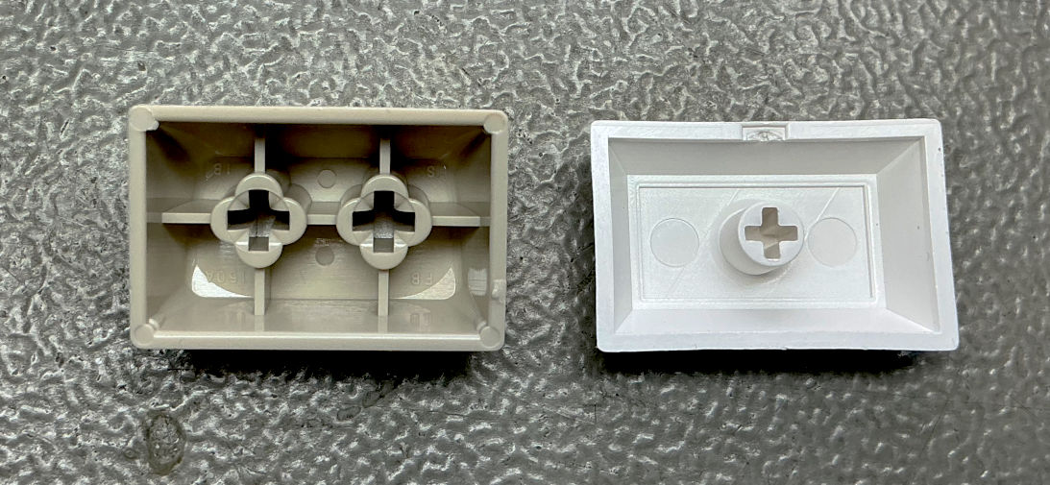
Figure 1: Old versus new 1.5U keycap
The solution is that the switches can be installed in either the off-center or center position (see Figure 2). To achieve this, the switches are simply rotated by 90°. This does not affect their operation, since the keycap connector is symmetrical.
The SW**A position is the center position, while SW** is the original off-center position.
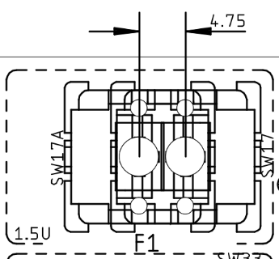
Figure 2: Alternative switch positions for the 1.5U keys
Now it is time to talk about the U. It is a unit used to specify key spacing.
Since the early 20th century, typewriter keys have had a spacing of ¾ inch (19.05 mm). This did not change with the transition to computer keyboards. The spacing was defined as 19 ± 1 mm in DIN 2111 from 1927, DIN 2139 from 1976, and ISO 1091 from 1977.
A 1U keycap fits a key with a 1U spacing. 1.5U keycaps are used for the SHIFT, CONTROL, RESTORE, and F-key keys.
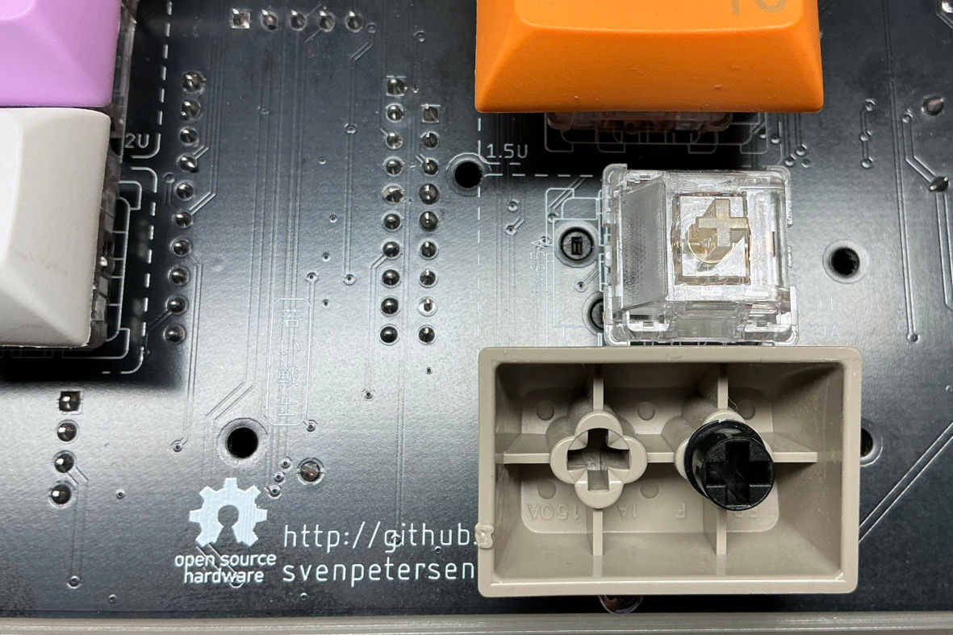
Figure 3: An original F7/F8 keycap with an adapter pin in position. The switch is mounted respectively (PCB Rev. 1 Hot Swap)

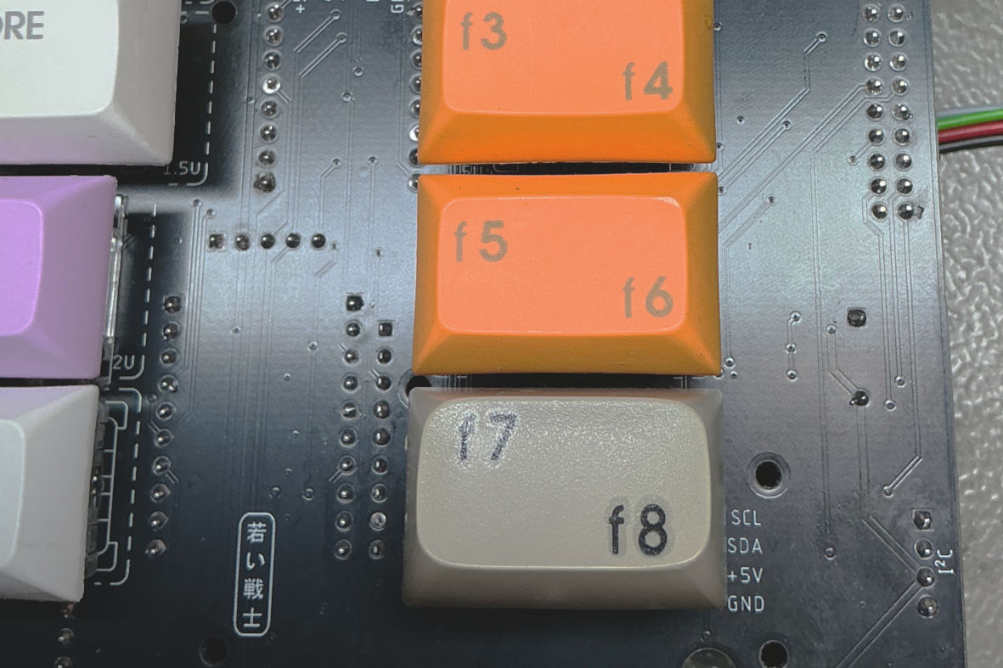
Figure 4: The original keycap mounted on switch

The Space Bar, PREV, NEXT
The original space bar is 9U wide, which I could not find available anywhere. I therefore decided to use a 7U space bar, which is available from several sellers on AliExpress. The remaining 2U are used for two additional 1U keys, PREV and NEXT, which can be used for switching between Kernals or LED modes.

Keycap Profiles
There are several keycap profiles available (Figure 5). Except for the CBMStuff keycaps, all other profile types differ from the original keycaps. Some profiles use a different keycap shape for each row of the keyboard, which would require ten different types of keycaps: four different 1U keycaps, four different 1.5U keycaps, one 2U keycap, and one space bar.
I have only looked for blank keycaps on AliExpress, and all the ones I found were DSA profile keycaps. At least this profile offers all the required keycap sizes.
The material of choice is PBT. It is well suited for applying legends, including processes involving heat, and it also has a pleasant feel.

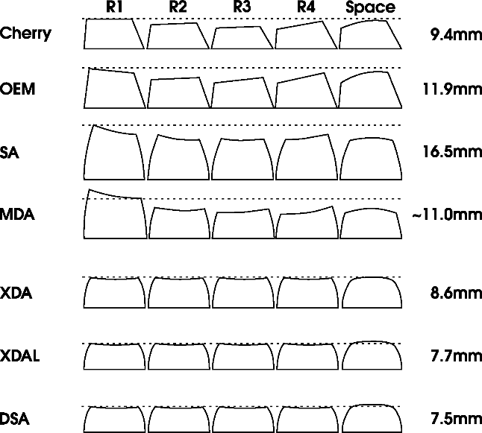
Figure 5: Different keycap profiles

The Switches
There are many mechanical switches available, offering different click characteristics and actuation-force profiles. I am not a “keyboard enthusiast,” so I do not have any particular preferences in this regard. I have tried switches ranging from budget models to somewhat more expensive ones and found them all quite good—and definitely better than the original keyboard. Even the €0.25 switches were perfectly acceptable.
Most importantly, the switches must be 5-pin switches. All switches have two electrically relevant pins and one plastic pin for centering. Since I did not design a separate mounting plate for this keyboard, the switches rely on two additional plastic pins, making a total of five pins, to position themselves accurately.
A mounting plate is a purely mechanical component made of metal, plastic, or FR4 (the material used for PCBs). It provides a second level, 5 mm above the actual PCB, with square cutouts for the switch bodies.
I once built a keyboard for 3-pin switches using a second PCB as the mounting plate. Due to the milled cutouts, this was several times more expensive than the keyboard PCB itself. Therefore, 5-pin switches are by far the better choice for this design.
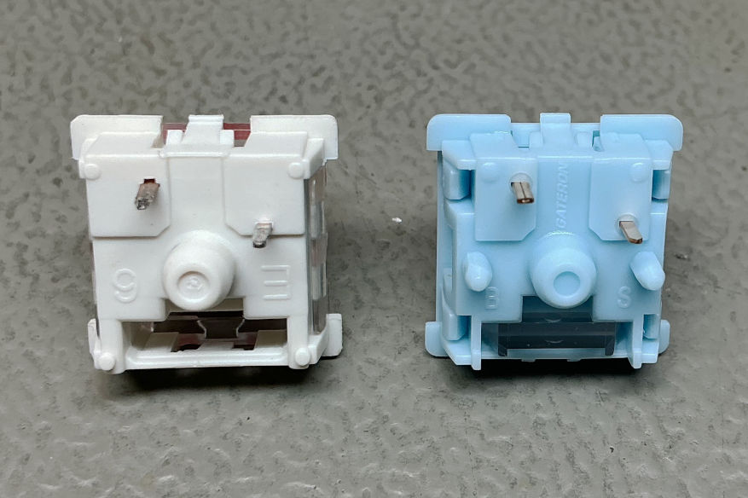
Figure 6: 3 pin versus 5 pin switches (right)
When choosing the switches, avoid 3-pin switches as well as magnetic switches. Magnetic keyboard switches require Hall-effect sensors, which are not supported by this PCB.
The Shift Lock key does not latch. As far as I know, latching keyboard switches are no longer manufactured. Even if you can still find them, they are prohibitively expensive, costing more than €30 each.

Stabilizers
The original space bar stabilizer consists of a spring-steel wire anchored to the plastic frame and guided through slots in two plastic pins located on the left and right underside of the space bar. It prevents the long keys from tilting or binding when pressed.
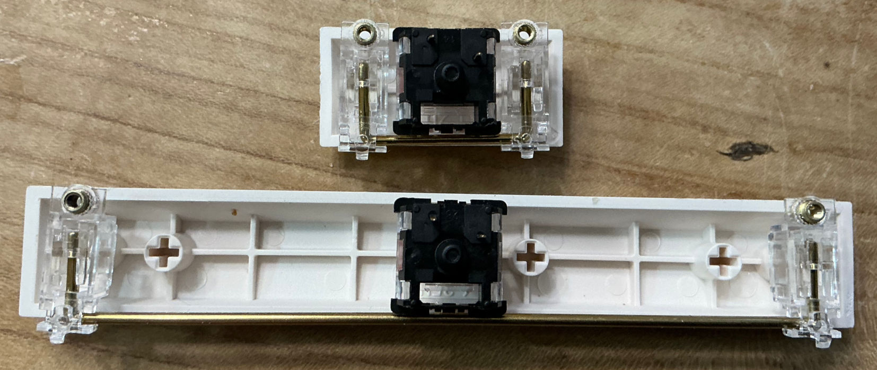
Figure 7: Stabilizer below space bar and RETURN keycap
The space bar stabilizer is essential; for the RETURN key, it is optional in my opinion.
The stabilizers are the most expensive components of this project. You can expect to pay €8 to more than €20 for both. It is important to buy a 7U stabilizer for the space bar—not a 6.25U stabilizer—and a 2U stabilizer for the RETURN key. They are often sold as a set.
Screw-in stabilizers are the best choice. There are also stabilizers that snap into the holes in the PCB; both types are suitable. Make sure the stabilizers are designed for a 1.6 mm PCB, not a 1.2 mm PCB.
Plate-mount stabilizers are not suitable, since this design does not use a mounting plate.
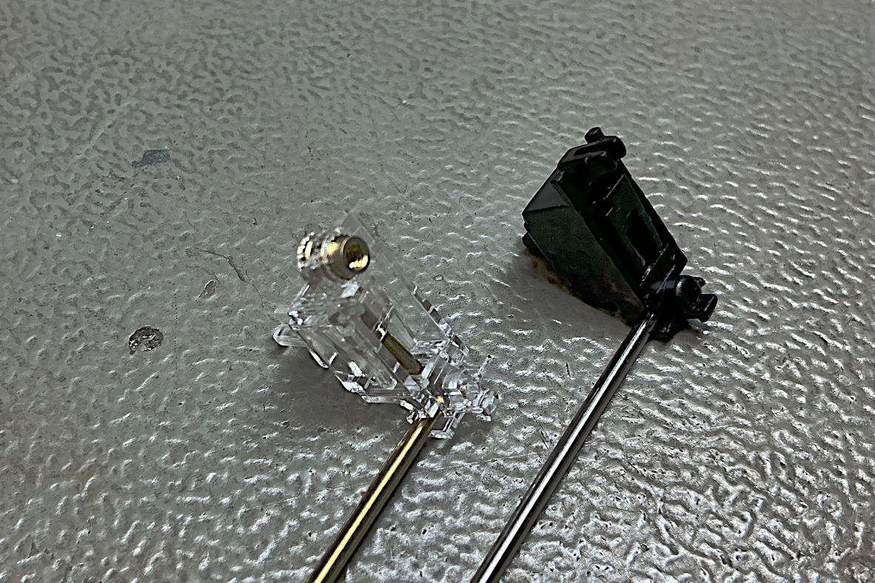
Figure 8: Stabilizer with mounting screw vs snap-in
The stabilizers are mounted in different orientations due to space constraints. The wire runs above the space bar switch and below the RETURN switch (Figure 9).
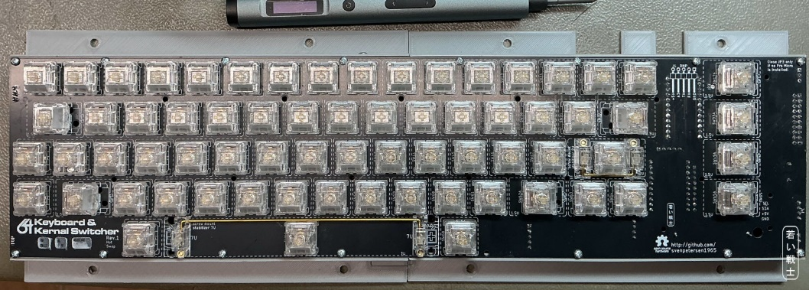
Figure 9: Stabilizers mounted on the keyboard
Figure 10 shows a screw-in stabilizer mounted on the bottom side of the PCB. One side has a hook that must be hooked into place first. The other side fits through the corresponding mounting hole. Once the stabilizer sits flush against the PCB, it can be secured with the screw. The plastic insulating washer should be used.
A 9U stabilizer is only required for the original spacebar. The C64 Ultimate and Blingboard64 spacebar works with a 7U stabilizer.
Find additional information in the /9U_stabilizer/ subfolder of this repository.
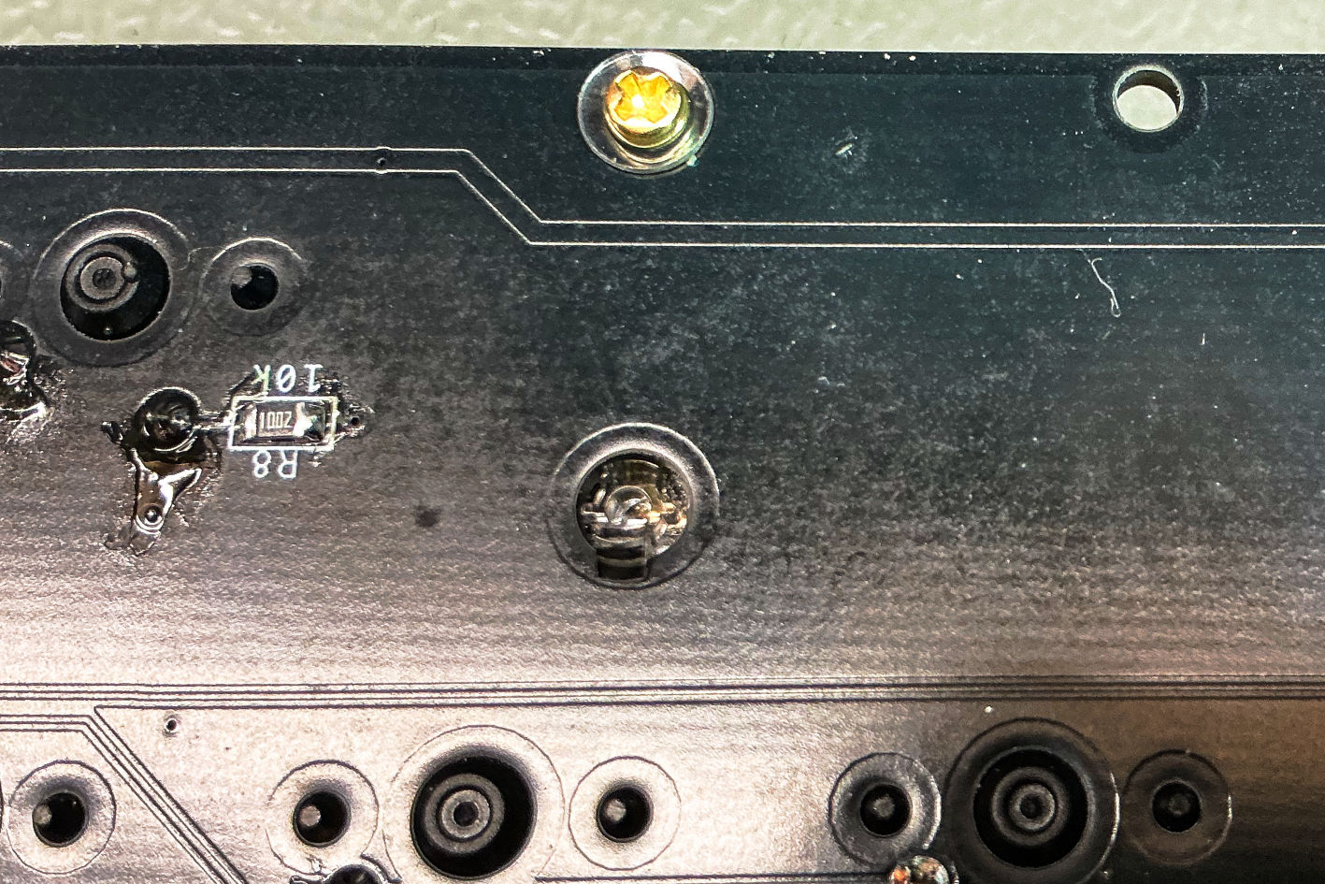
Figure 10: Bottom side of the mounted stabilizer (screw mount)

The Circuit

Block Diagram
This is the block diagram of the C64 keyboard project. The original keyboard consists only of the switch matrix (without PREV and NEXT), the interconnections, and the keyboard connector at the end of the cable.
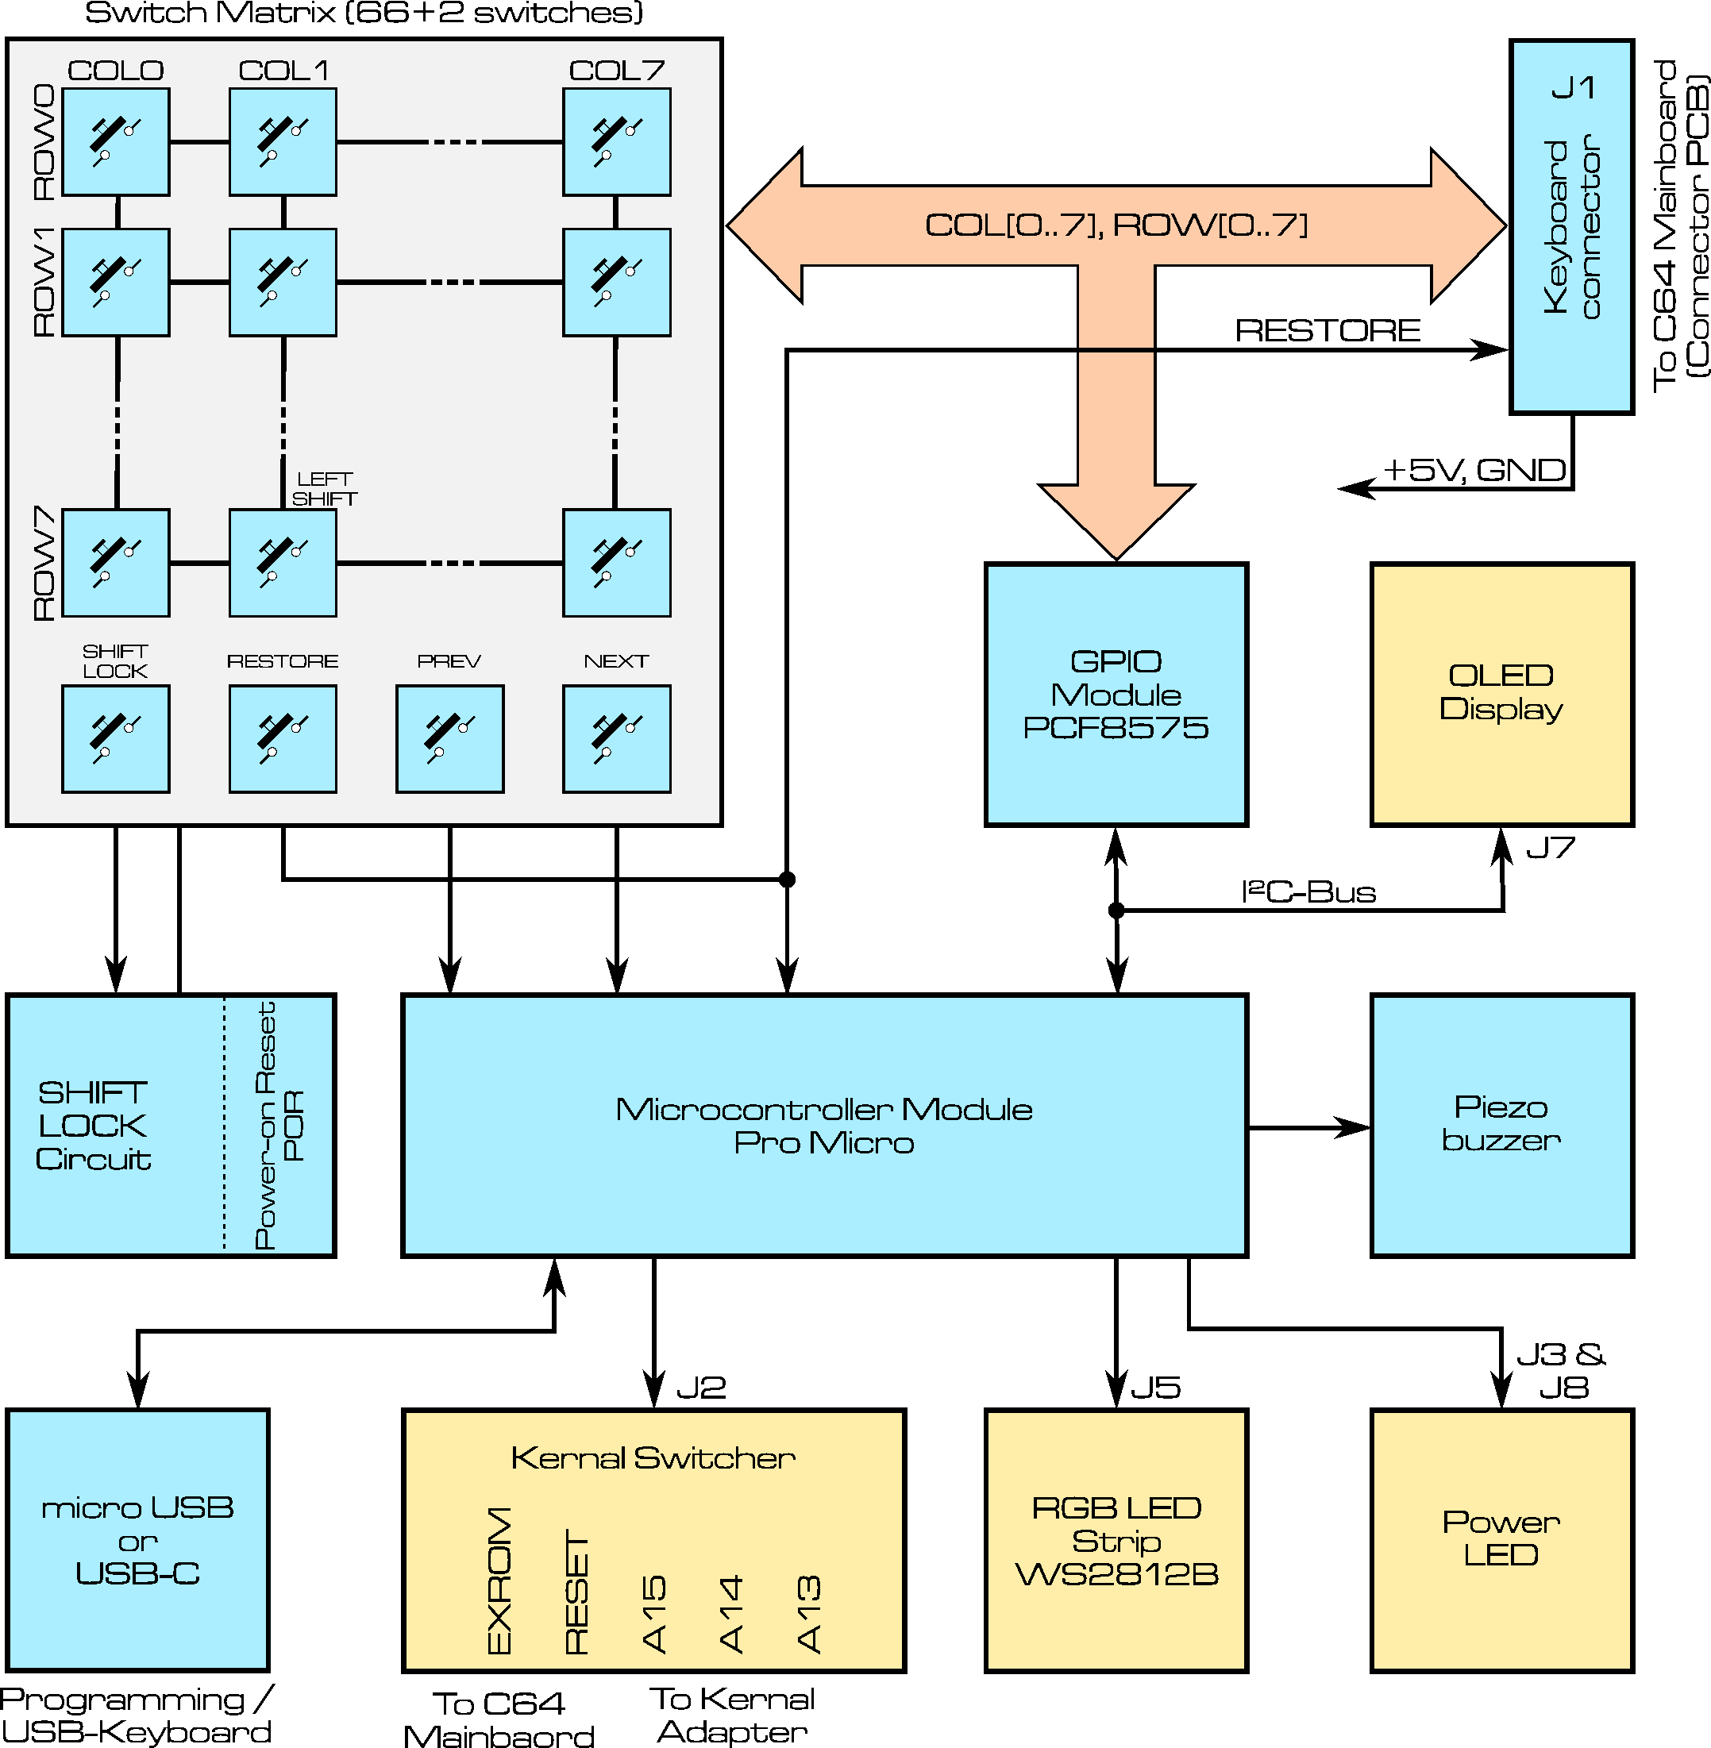
Figure 11: Block Diagram of the C64 Keyboard
The circuit is scalable to suit your needs. The minimum configuration consists of the switch matrix (without PREV and NEXT), the keyboard connector, and the Shift Lock circuit.
If you do not want the beeps, simply leave out the piezo buzzer. If you do not need a display, do not connect one; the software must then be configured accordingly.
If you do not want to use the keyboard as a USB keyboard, the GPIO module is not required.

Keyboard Matrix and Output Connector
The key switches are connected in an 8 × 8 matrix, consisting of 8 rows and 8 columns. The RESTORE key has a dedicated pin on the keyboard connector. This is identical to the circuit of the original keyboard.
The output connector is a 2 × 10-pin, 90° box header. I chose this type of connector because it connects to the ribbon cable via an IDC socket connector. This requires only a vice to compress the connector and does not require any specialized crimping tools.
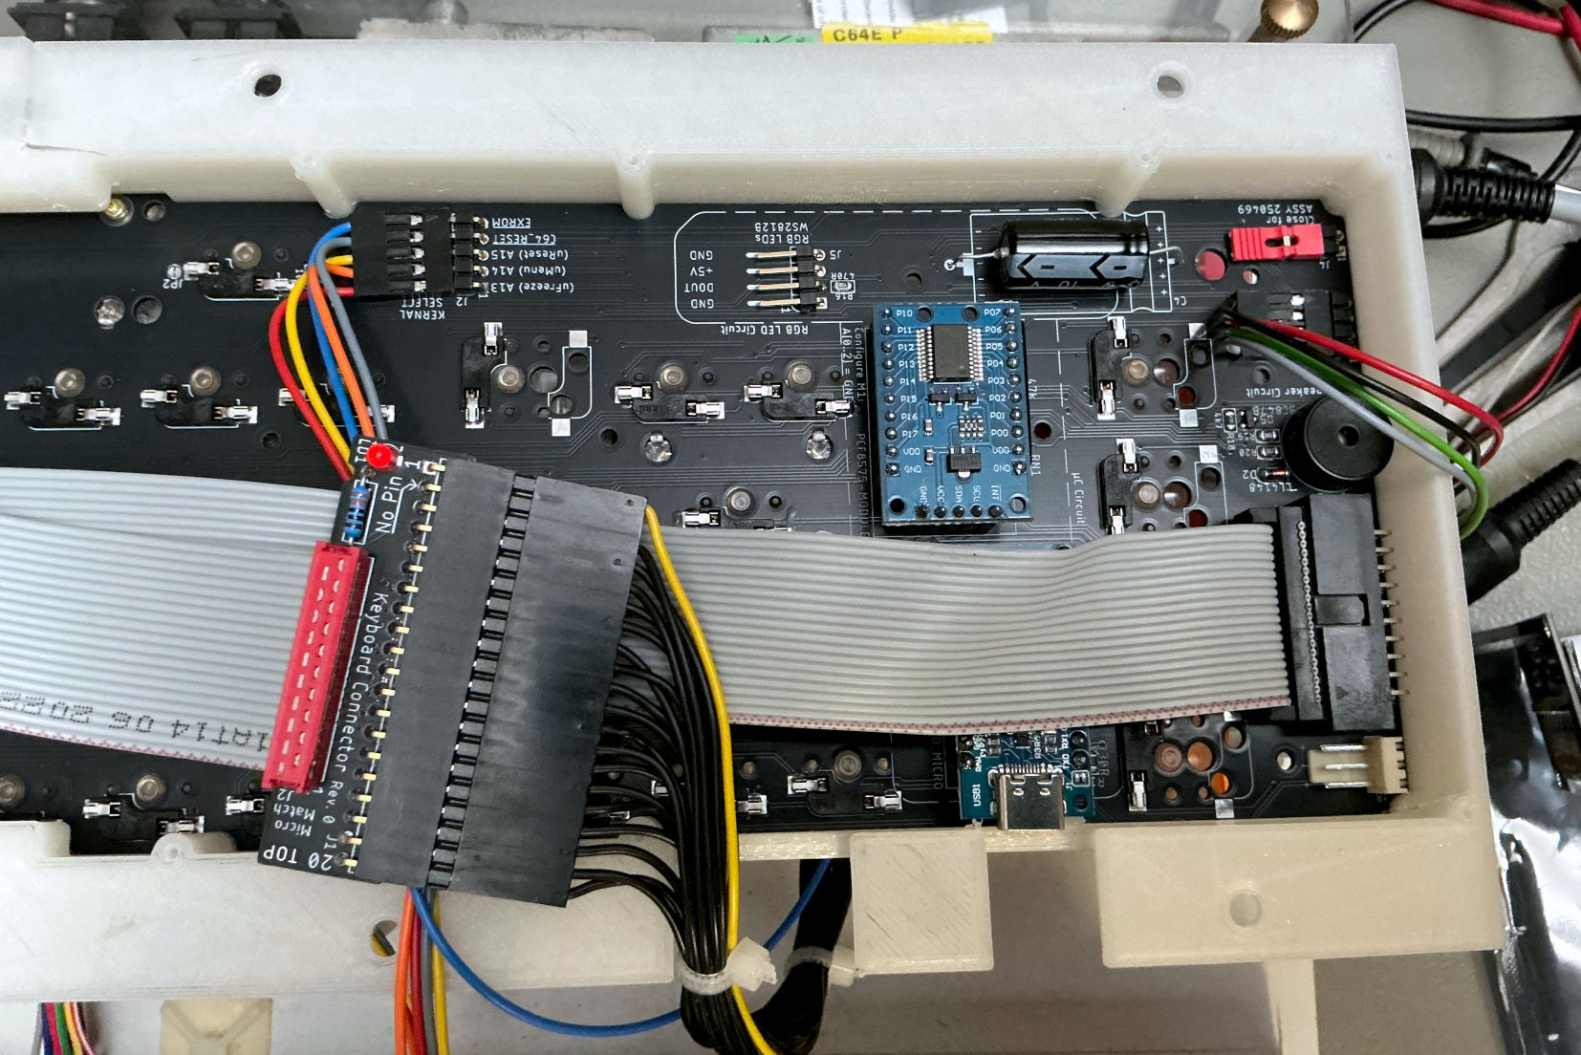
Figure 12: The keyboard connector with the ribbon cable and the connector PCB (Rev 1 with hot swap sockets)

The SHIFT LOCK Switch
The SHIFT LOCK key does not latch like on an original keyboard. As far as know, latching Cherry MX compatible keyboard switches are no longer being manufactured. Even in case you find a used one of them, they are prohibitively expensive (over 30€ each).
This is the reason for using a standard switch with a little circuit. In Rev. 0, this is not 100% reliable. Sometimes the keyboard starts up with shift lock on. The circuit works perfectly when powering the keyboard from a lab power supply. Only installed in a C64, it sometimes does not work properly. The problem will be resolved in a later revision of the PCB. There is a simple fix with a botch wire, though (see The Power-On Reset Botch).
The status of the SHIFT LOCK switch is indicated by an LED, which is attached to this switch. It should be a high brightness LED, so even in daylight it can be noticed.
The Power-On Reset (POR) circuit is only required if the keyboard is intended to be used without the Pro Micro controller, as a “passive” matrix keyboard.
An installed Pro Micro resets the Shift Lock circuit. Therefore, if M2 is installed, the “expensive” POR circuit (IC3) can be left unpopulated.
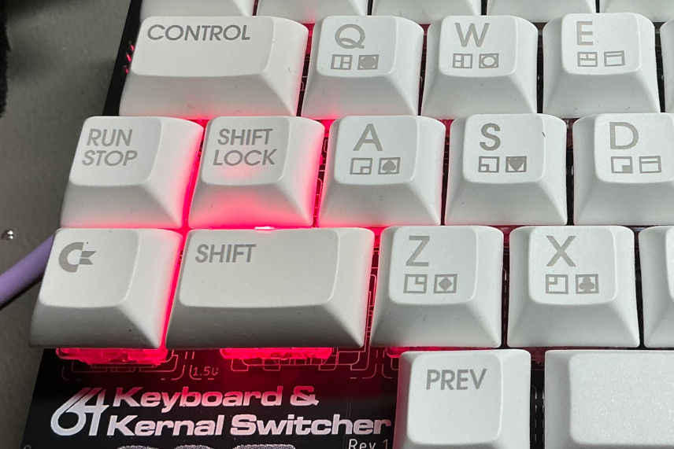
Figure 13: SHIFT LOCK status LED
I have tried normal LEDs in this position. In a dimly lit room, there was no problem, but in a well-lit room, their visibility was poor.
The current-limiting resistor for the LED is R1. It is calculated as 100 Ω for an LED with a 2 V forward voltage drop (red or green) and a forward current (IF) of 30 mA.
A standard LED may not be suitable for this relatively high current. A lower current, and therefore a higher resistor value (e.g. 150 Ω), may be more appropriate for normal LEDs.
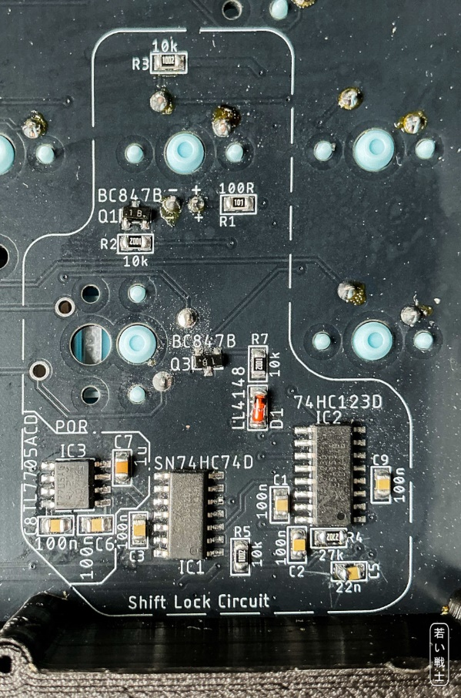
Figure 14: Shift Lock circuit Rev. 1, POR (power-on reset) not populated

The Micro Controller Module
The keyboard controller is a Pro Micro, which is available for about €5 and can be programmed via a USB cable (micro-USB or USB-C, depending on the model).
I strongly recommend a Pro Micro with a USB-C connector, as these are more robust in several respects. It is also preferable to choose a model where the metal connector bracket is secured with through-hole soldering rather than only with SMD pads. I have already broken off half a dozen micro-USB connectors myself.
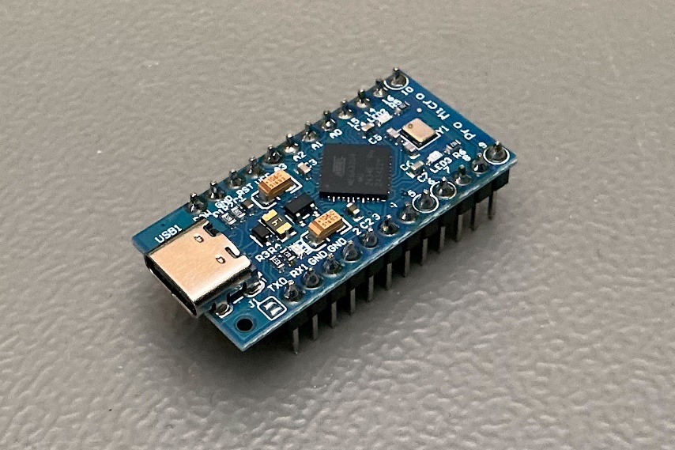
Figure 15: pro micro with a USB-C connector
The Pro Micro is programmed using the Arduino IDE via a USB cable. It is configured using #define statements at the beginning of the source code. Options that are not required can simply be commented out.
Adding // at the beginning of a line turns it into a comment, so configuring the software should be manageable even without a PhD in computer science.
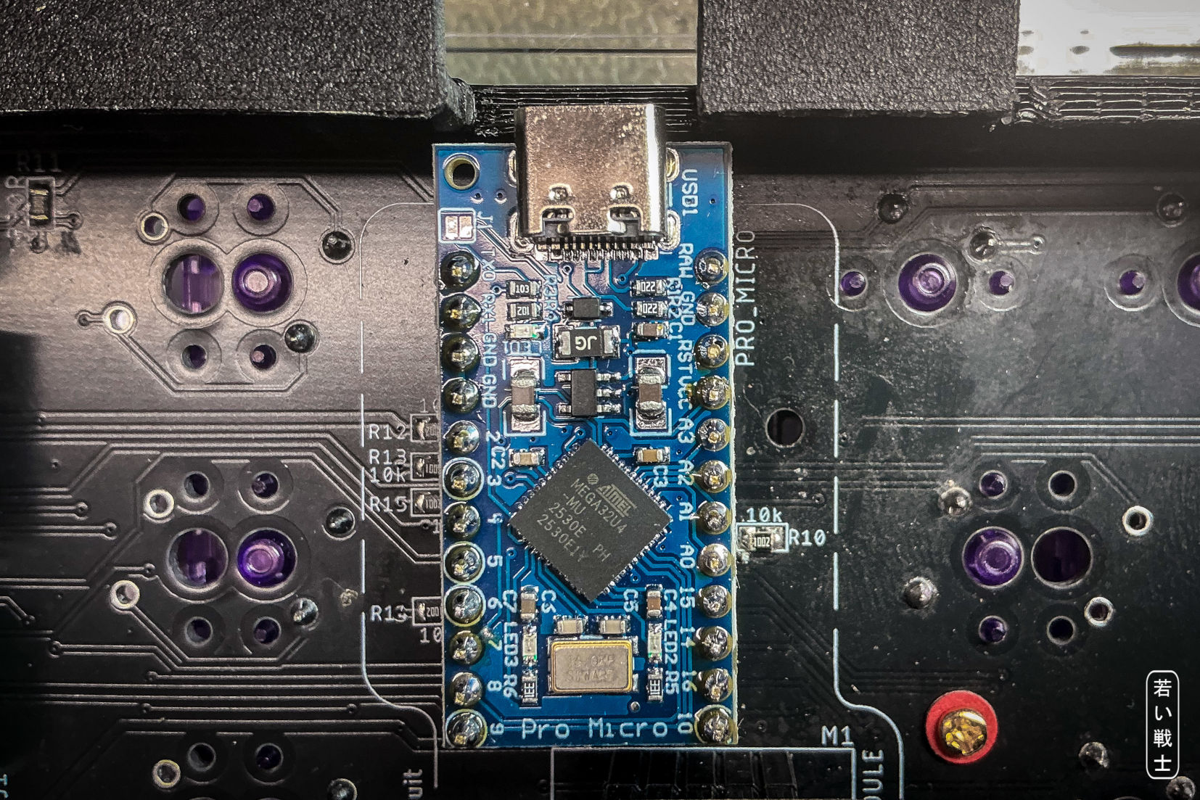
Figure 16:The pro micro on the PCB. The 10k resistors are required.
Without the Pro Micro, there is no Kernal switching, OLED display, PREV and NEXT keys, piezo buzzer, or LED strip. That is perfectly acceptable if these additional features are not required.

The Piezo Buzzer
The piezo buzzer is a small speaker that is not exactly Hi-Fi, but it provides useful audible feedback.
It emits a beep when RESTORE has been held long enough to trigger a C64 reset, and two beeps when it has been held long enough to trigger an EXROM reset. Different beep patterns are used when PREV or NEXT is pressed.
It can also play the “Are You Keeping Up…” jingle during startup if the corresponding #define statement is enabled.
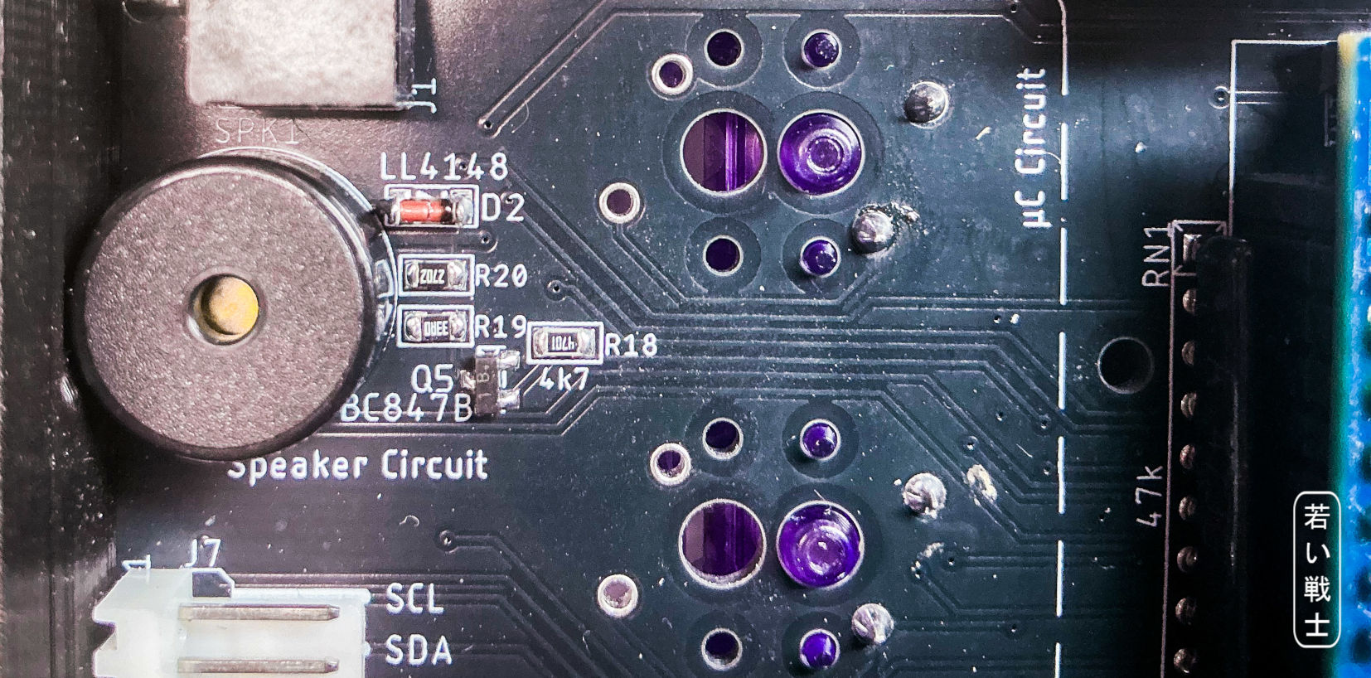
Figure 17: The speaker (piezo buzzer) circuit.

The Power LED
There are two connectors for the power LED, one on each side of the PCB (J8 and J3). This allows you to choose the side that best suits your installation and reduces the number of cables between the top and bottom of the keyboard to the keyboard cable alone.
The power LED is controlled by the Pro Micro and blinks in sync with the piezo buzzer beeps. This provides useful visual feedback, especially in noisy environments where the buzzer may be difficult to hear.

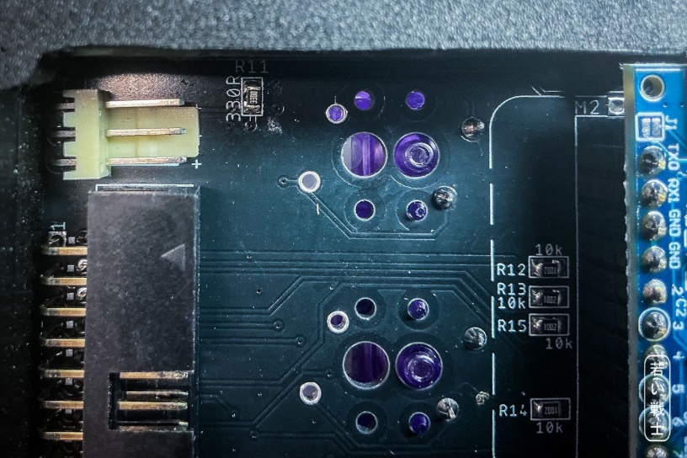
Figure 18: The power LED connectorJ8 (top left)
If there is no controller, the LED can be powered permanently by closing the JP3 solder bridge on the top side of the PCB. Only close JP3 if no Pro Micro is installed; otherwise, the controller may be damaged.
The current-limiting resistor is R11, which is 330 Ω by default. This provides a forward current of approximately 10 mA for a standard red LED.
Only one power LED should be used. Using two LEDs may cause them to be dim, have different brightness levels, or fail to light at all.

The GPIO Module
The purpose of the GPIO module (M1) is to provide the Pro Micro with the additional I/O pins required to scan the keyboard matrix 125 times per second when the keyboard is used as a USB keyboard for VICE.
In all other operating modes, the GPIO module is not required. Consequently, the pull-up resistor network RN1 is not required either.
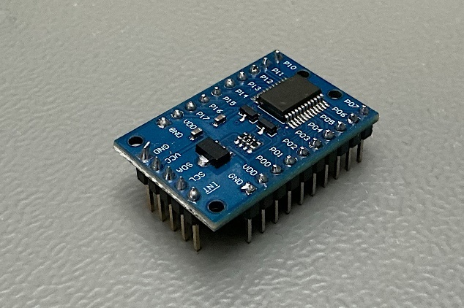
Figure 19: The PCF8575 GPIO module
The module is connected to the pro micro via the I²C bus. To access any IC or module on this bus, a properly set I²C slave address is required to properly access the module. This slave address of the module is configured by solder bridges on the bottom side of the module PCB. They (A0…2) should all be closed to the GND side (Figure 20). That sets the slave address to 20_{HEX}/0x20.
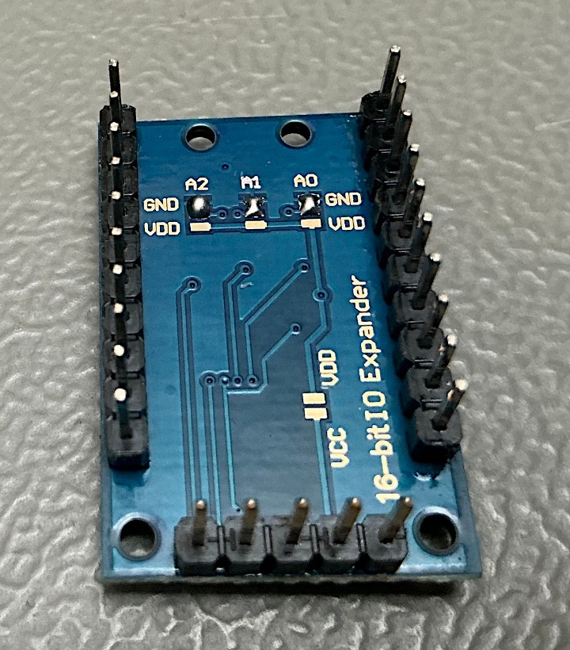
Figure 20: properly configured PCF8575 module
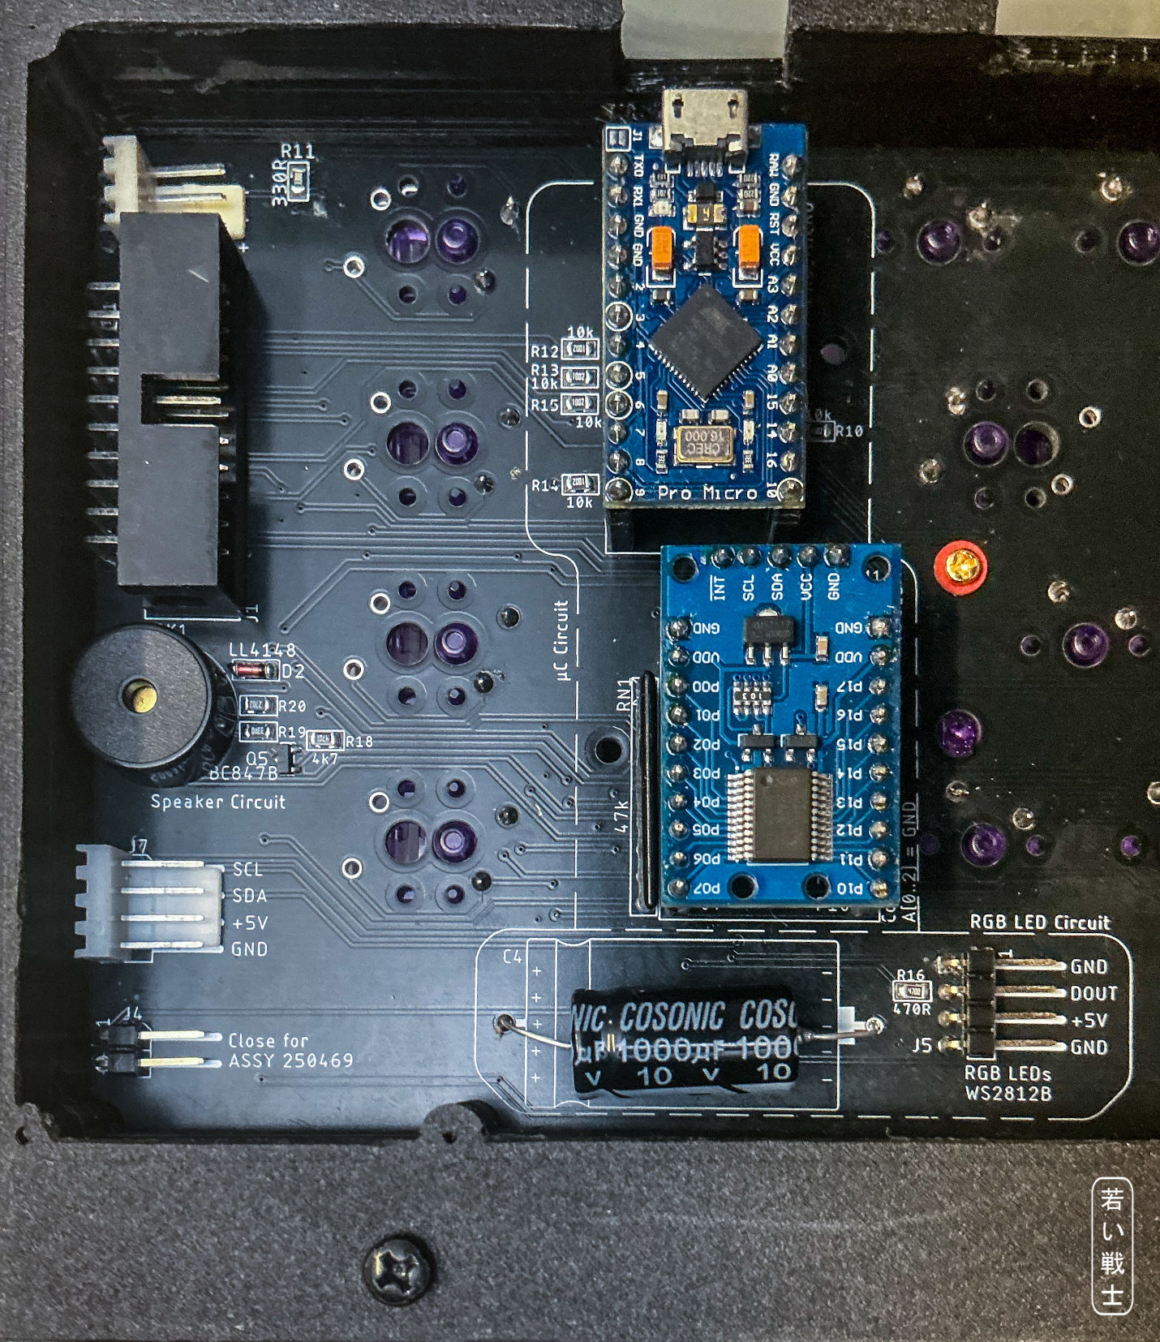
Figure 21: The µC circuit including the PCF8575 GPIO module M1 and resistor network RN1

The Kernal Switcher
The Kernal switcher is controlled by the RESTORE, PREV, and NEXT keys. The switching logic is handled by the Pro Micro controller.
It can switch between the Kernals stored in an EPROM on a Kernal adapter (Figure 22). A 27C512 EPROM can hold up to eight Kernals.
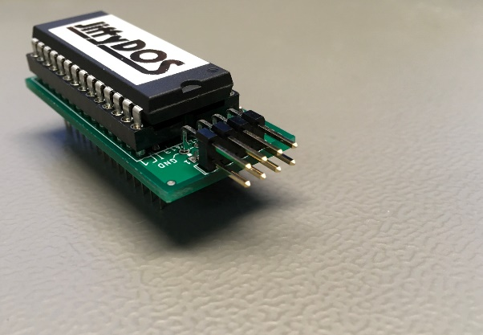
Figure 22: Kernal Adapter
I have created two different versions, both of which are available on GitHub:
- C64 Kernal Adapter/Switch Long Board
- C64 Kernal Adapter/Switch Short Board
The reason for the two different versions—for short boards (ASSY 250469) and long boards (all other ASSY numbers) is that the short boards use a combined Kernal and BASIC ROM (16 kB), whereas the long boards have two separate ROMs (8 kB each).
A 27C512 Kernal EPROM has a capacity of 64 kB and can therefore hold eight 8 kB Kernals on a long board. On a short board, the lowest 8 kB memory slot contains the BASIC ROM, leaving the subsequent seven slots for Kernals.
The three highest address bits, A[13..15], are used to select the active Kernal. The Kernal adapters mentioned above have jumpers that normally select the Kernal. However, these address lines can also be controlled by the keyboard. The lower row of pins on the adapter, from left to right, is A13, A14, A15, and +5 V. The +5 V connection is not used.
A cable from the keyboard to the Kernal adapter (Figure 23, yellow/orange/red wires: A15, A14, A13) already provides the three address signals. A RESET connection is also required.
RESET can be tapped at a suitable point near pin 3 of the user port. Usually, there is a via nearby that can be used to solder in a single-pin header. This is the grey wire in the upper part of Figure 23
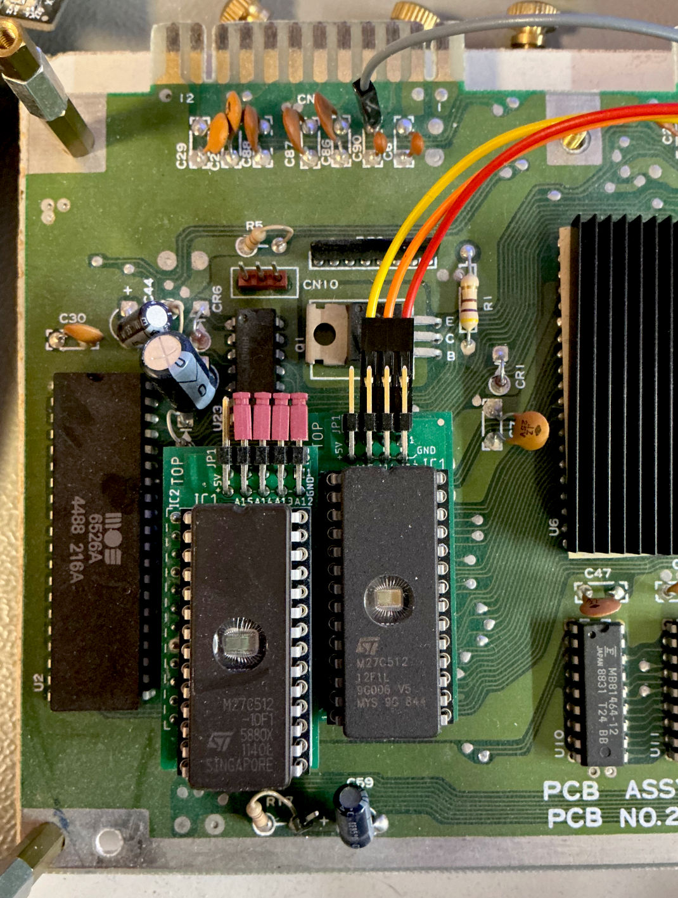
Figure 23: Character set (left) and Kernal adapter (right) on a short board.
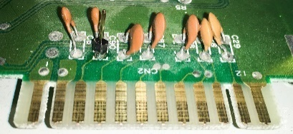
Figure 24: Reset Pin on ASSY250469 (short board)
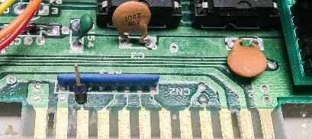
Figure 25: Reset Pin on ASSY 250425 (long board)
An EXROM connection completes the functionality. An EXROM reset can be useful for getting out of fake cartridge signature (CBM80) situations used by some games as copy protection.
It is best to tap the EXROM signal directly at the Expansion Port connector.
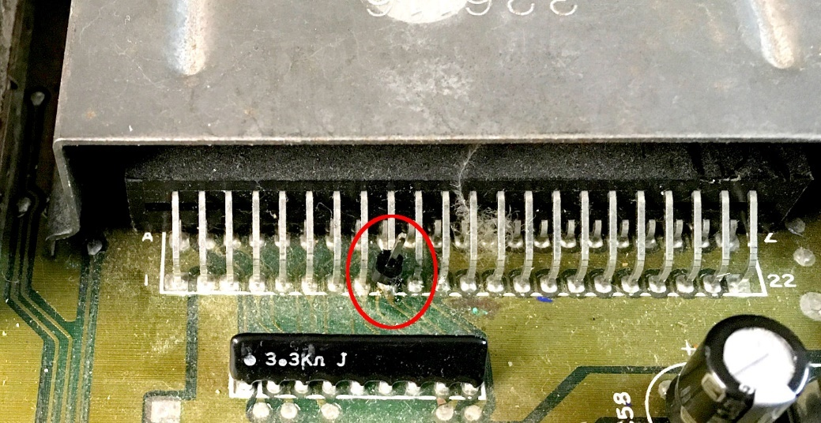
Figure 26: EXROM pin soldered to pin 9 of the expansion port
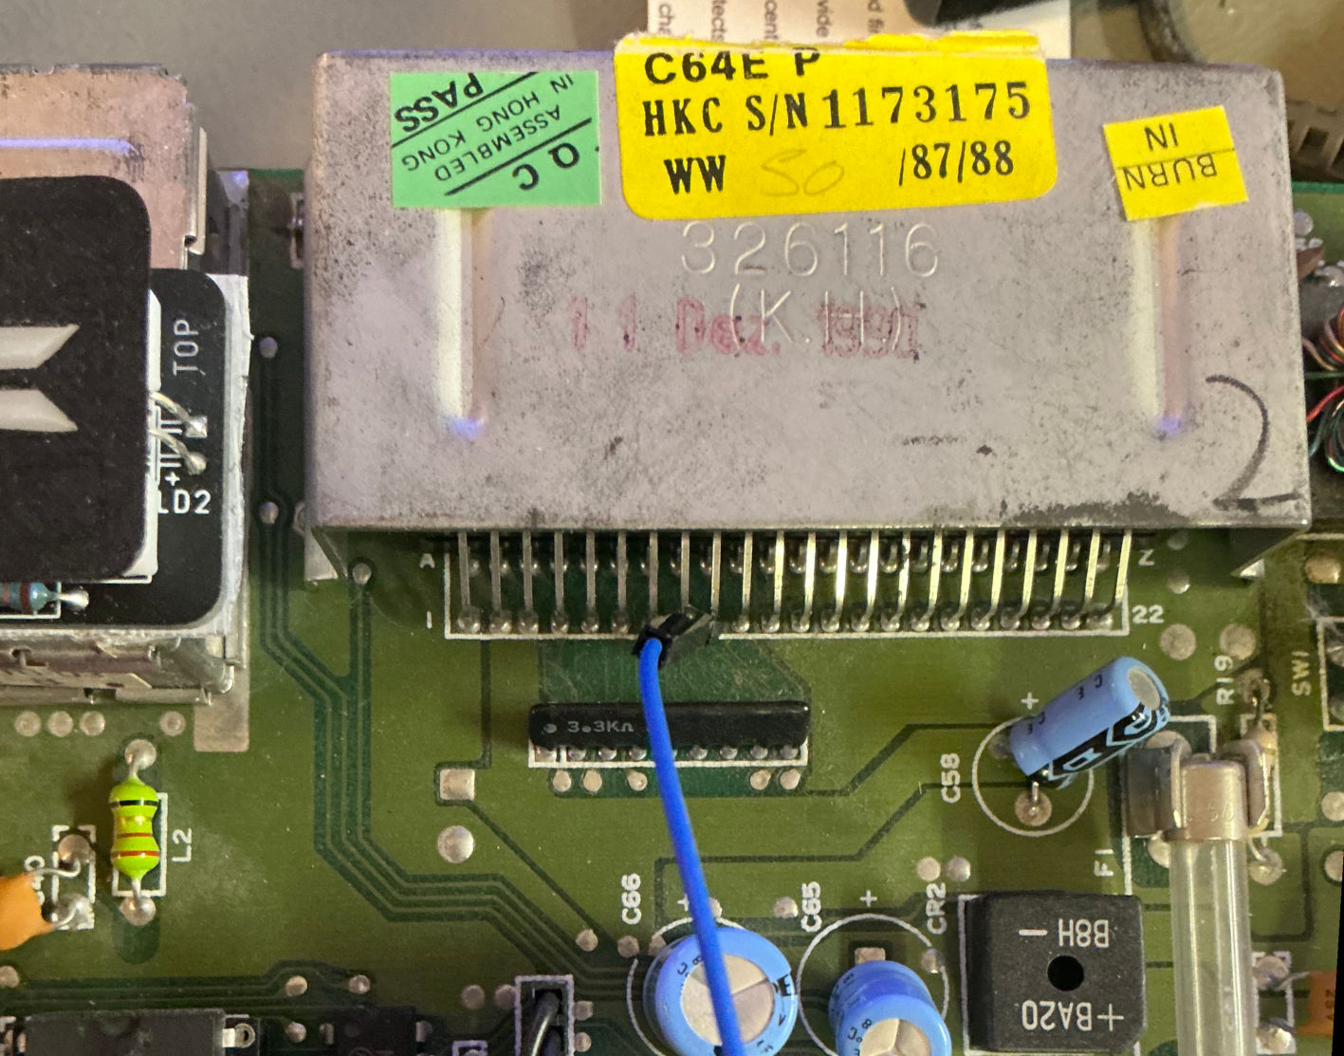
Figure 27: EXROM wire connected to the pin header
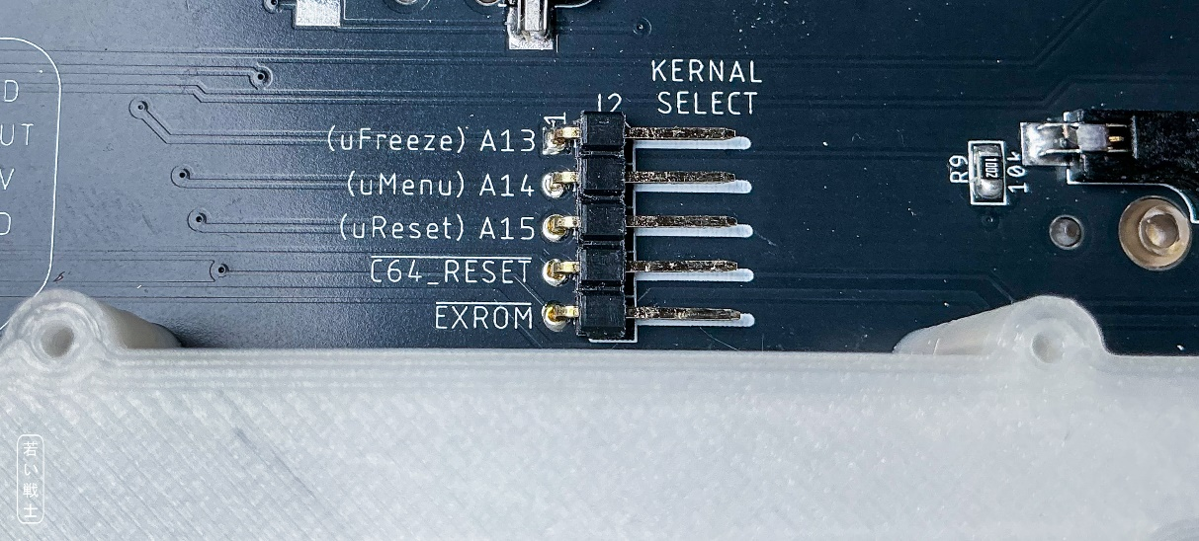
Figure 28: The connector for the Kernal switcher J2
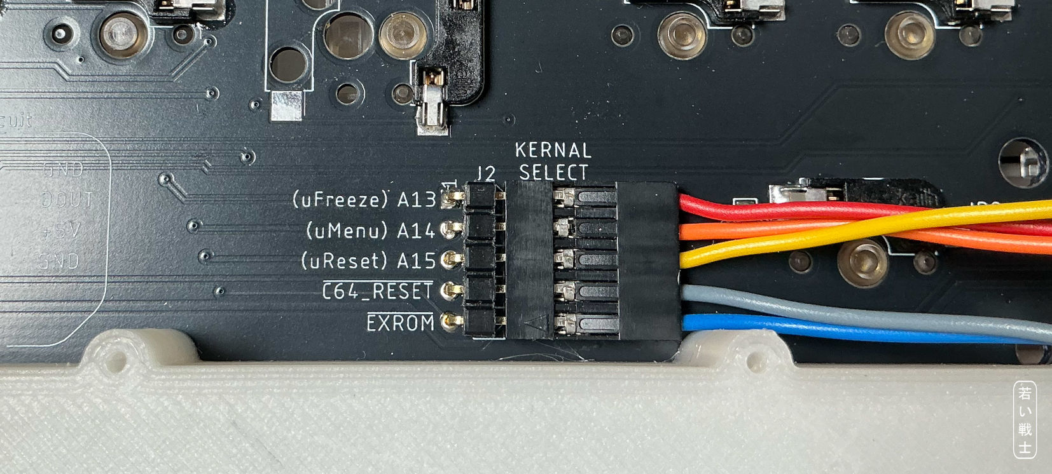
Figure 29: J2 with Kernal Switcher Cable
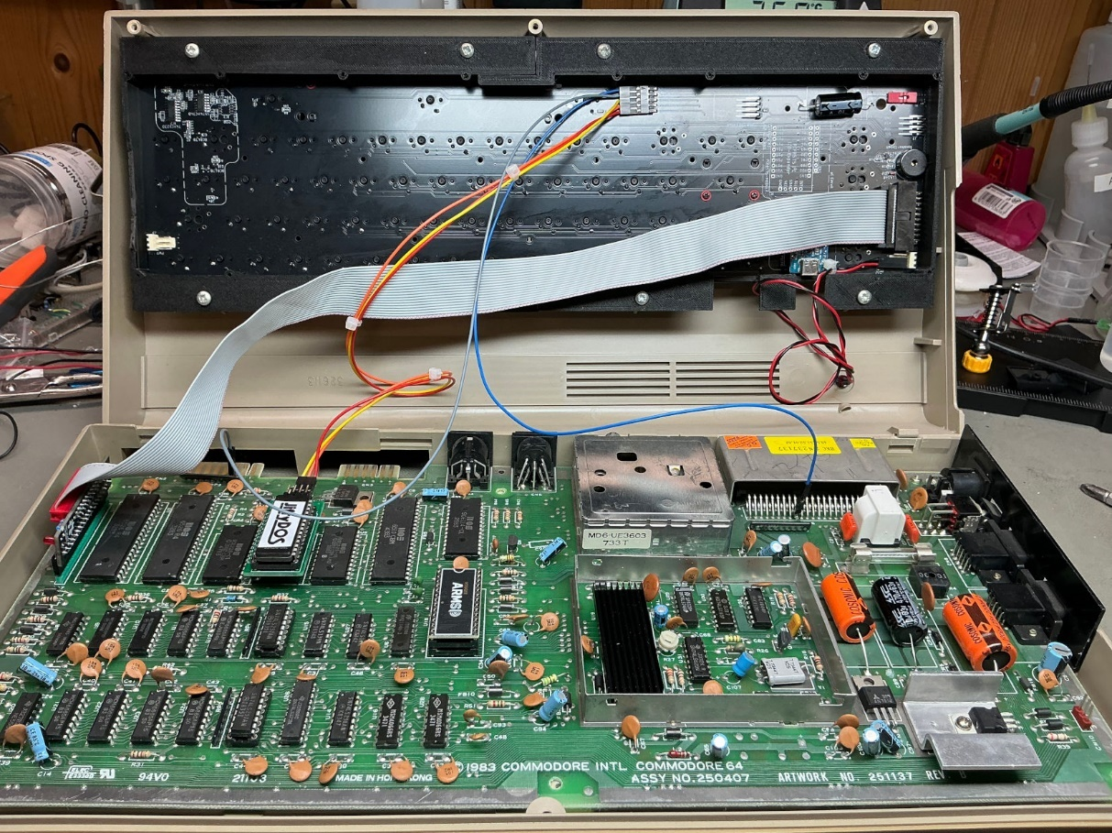
Figure 30: A properly wired-up C64 Breadbin with the installed Kernal cable

Ultimate Buttons
When connected to the Ultimate 64-Elite -II, the Kernal Switcher is not required. Instead, the buttons pin header on the mainboard is controlled by the keyboard (in case this option is enabled in the Software). Since the outputs are simulated open collector, the C64 keyboard can handle the required 3.3V logic of the Ultimate 64 or the C64 ultimate.
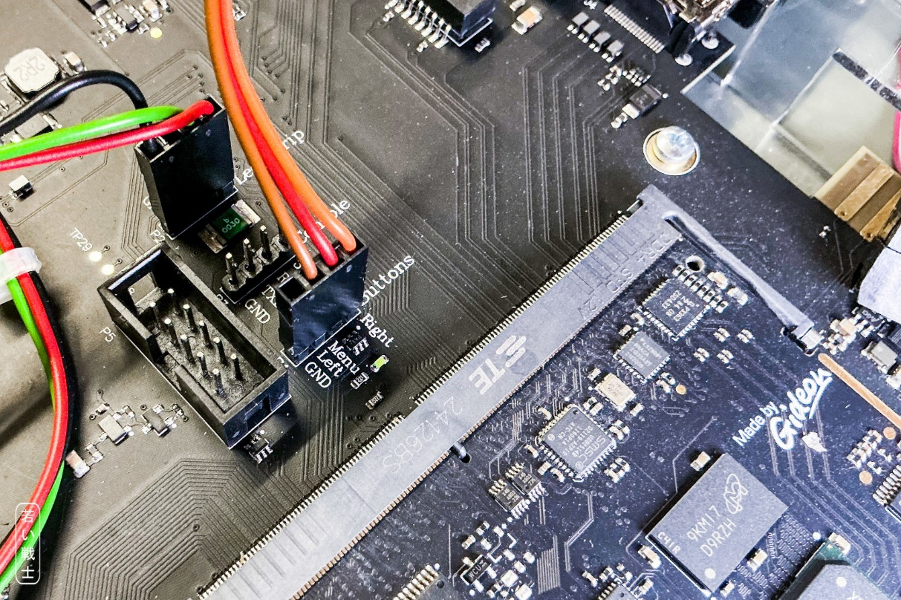
Figure 31: Ultimate elite II buttons pin header
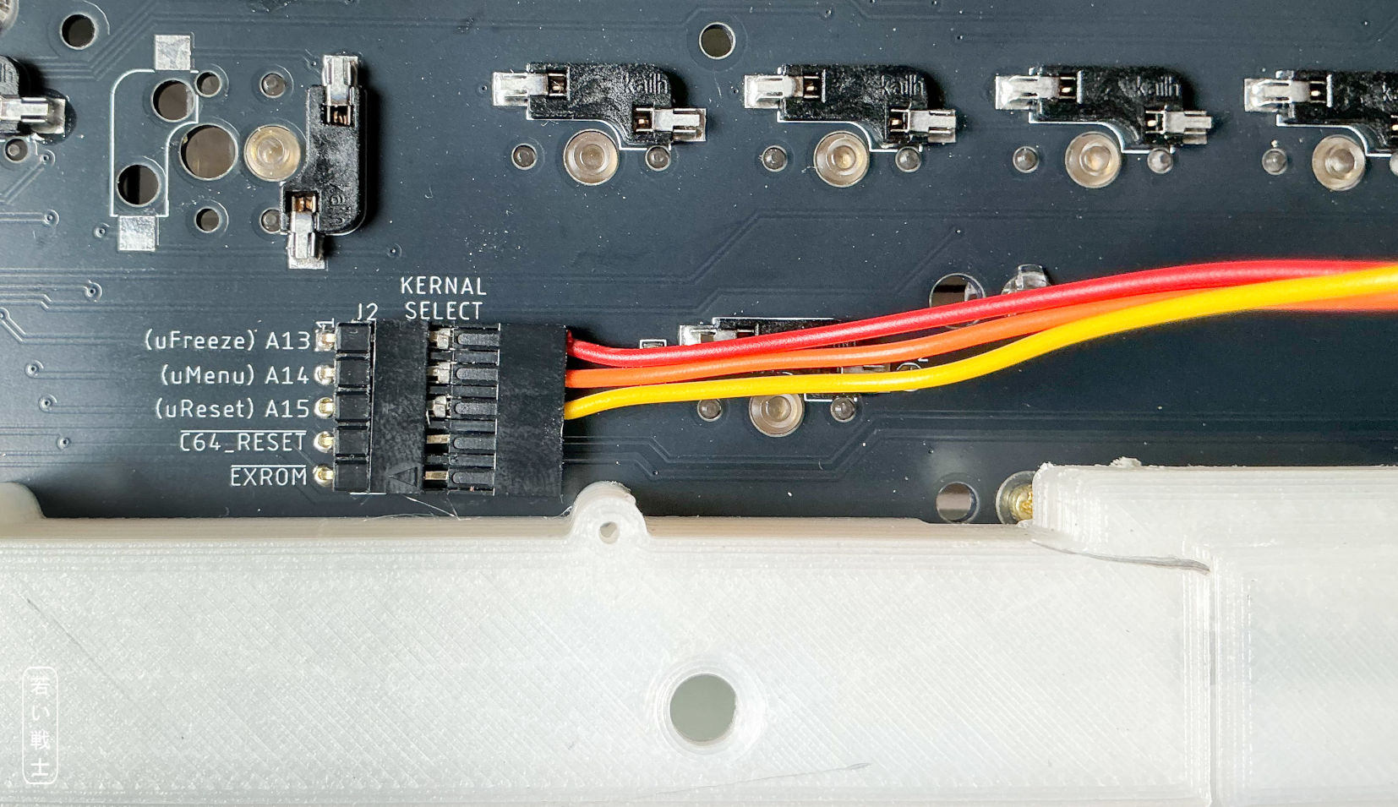
Figure 32: J2 with the Ultimate buttons cable
An important part of the Kernal Switcher is the jumper J4, that selects long board (no jumper placed) or short board (jumper placed).
An important part of the Kernal switcher is the J4 jumper, which selects the appropriate C64 board type:
- Long board: J4 open (no jumper installed)
- Short board: J4 closed (jumper installed)
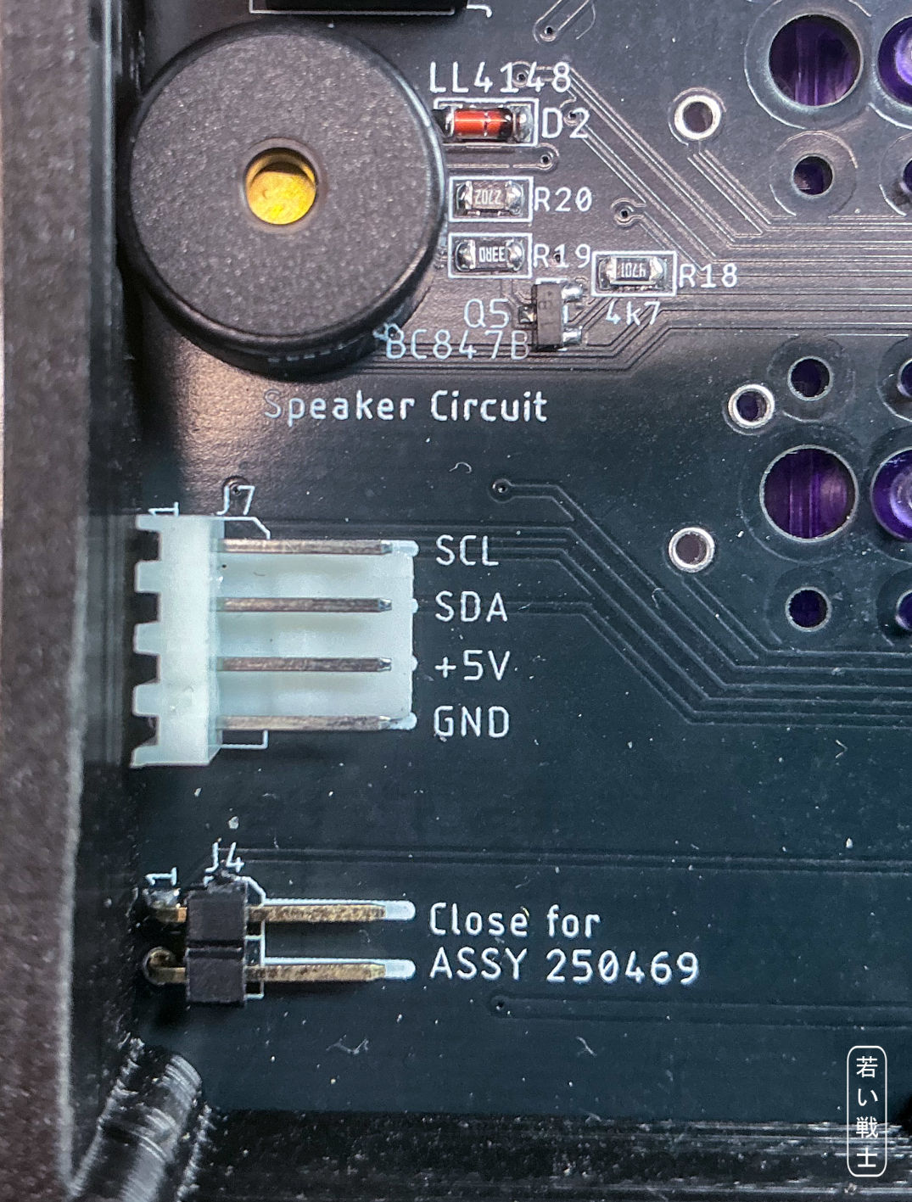
Figure 33: Jumper J4 and the I²C Bus connector J7
The reason for this distinction is that a 27C512 64 kB EPROM on a long-board adapter can contain up to eight Kernals, whereas the first 8 kB of the EPROM on a short-board adapter—at least on the adapter I designed—is reserved for BASIC. Therefore, the short-board adapter can contain only seven Kernals.
The J4 jumper prevents the keyboard from selecting the 8 kB BASIC block as a Kernal. Without this protection, selecting that block would result in a temporary black screen.

The RGB LED Strip
A free pin on the Pro Micro is dedicated to controlling a WS2812B-based RGB LED strip. The color and brightness of each individual LED can be controlled independently.
The Pro Micro contains 10 different light patterns, either using a rainbow spectrum (multicolor) or a single color with varying brightness. The patterns are designed to change slowly and smoothly, without distracting or nervous effects.
The length of the LED strip can be defined in the software's source code. It should not exceed 23 LEDs.
The computer's PSU must be capable of supplying the additional current required by the RGB LED strip. At full brightness (RGBbright = 255), the strip draws approximately 400 mA of additional current. A more moderate brightness setting is RGBbright = 32, which requires approximately 50 mA extra.
The RGB strip consists of WS2812B LEDs connected in a daisy chain. Each LED has a Din (data input) and Dout (data output). The strip must be connected with the Din side to the keyboard's J5 connector (Figure 36).
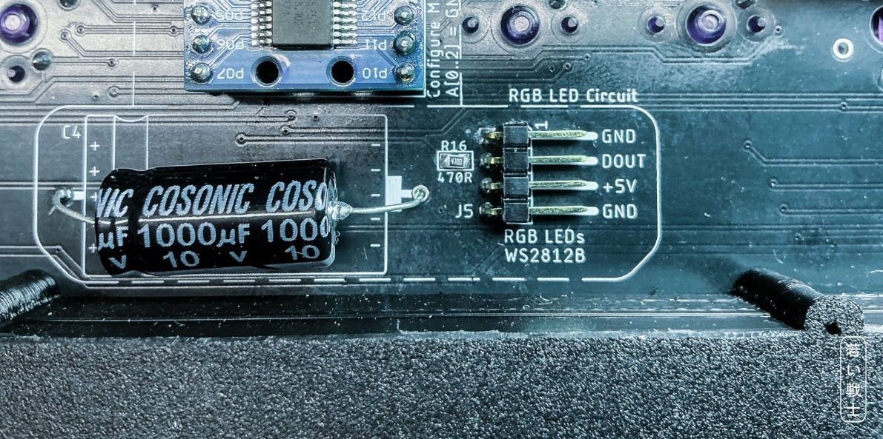
Figure 34: RGB LED Circuit
The RGB LED circuit consists of only a 1000 µF electrolytic capacitor, a 470Ω resistor, and the pin header itself.
If no RGB LED strip is connected, these components are not required.
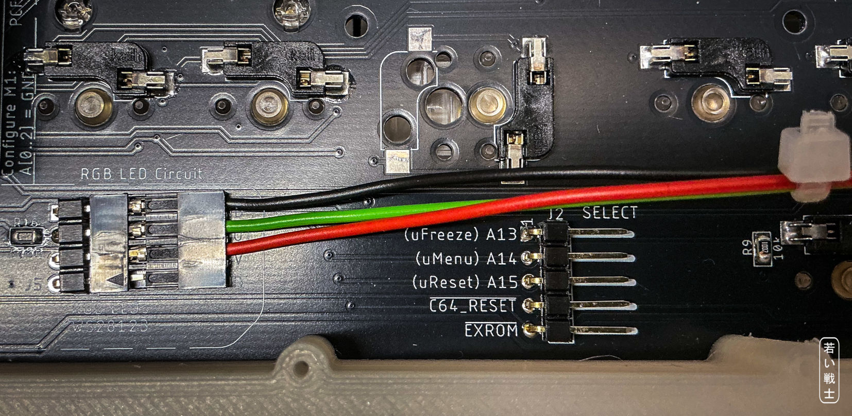
Figure 35: LED Strip Cable at J5 (Board version with hot swap sockets)
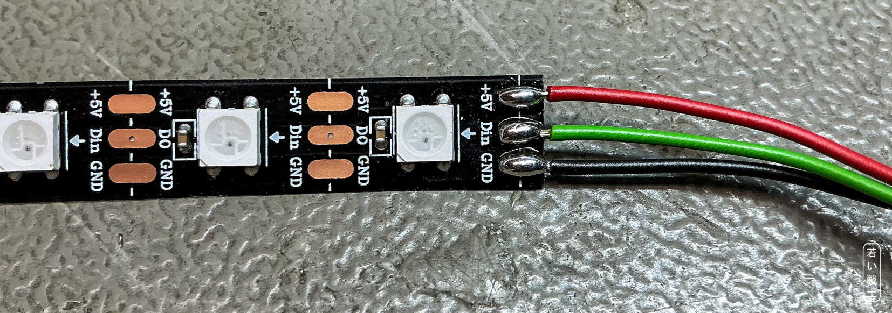
Figure 36: RGB LED Strip with soldered cable

I²C-Bus/OLED display
The I²C bus is a serial bus used to communicate with components, ICs, and modules within electronic devices. It can be used to connect various devices, such as displays and sensors.
I have integrated support for three different OLED displays into the Pro Micro software. The desired display can be selected in the source code.
Size | Resolution | Controller
0.91” | 128 x 32 pixel | SSD1306
0.96” | 128 x 64 pixel | SSD1306
1.3” | 128 x 64 pixel | SH1106

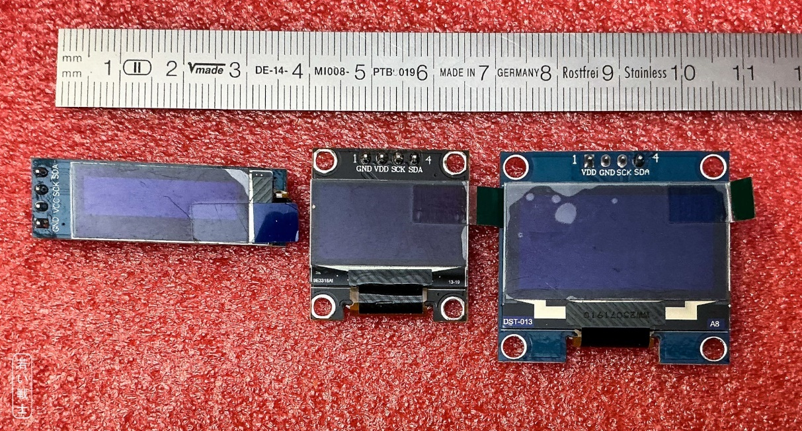
Figure 37: 0.91", 0.96" and 1.3" OLED Display
The display shows the currently selected Kernal and LED pattern (with software version v0.00). During startup, it displays the C64 logo and the software version.
When a RESET or EXROM RESET is triggered, the display indicates which type of reset was performed.
On an Ultimate 64, the FREEZE, MENU, and RESET button presses are also displayed.
The cable of the OLED display is a Dupont cable. It might be required to solder the cable to the display, depending on how you want to install it.
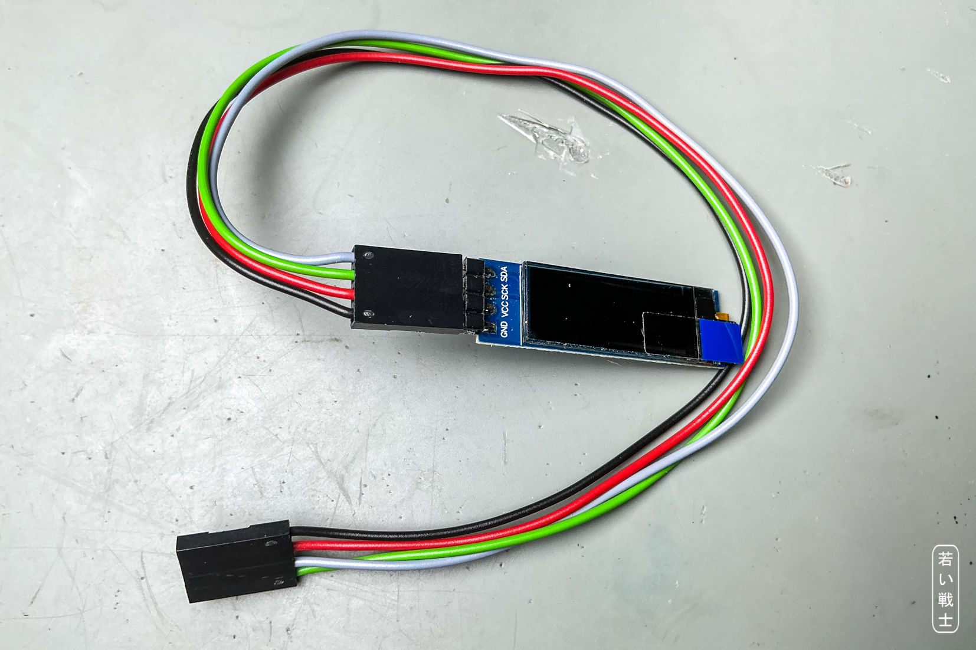
Figure 38: 0.91" OLED display with cable
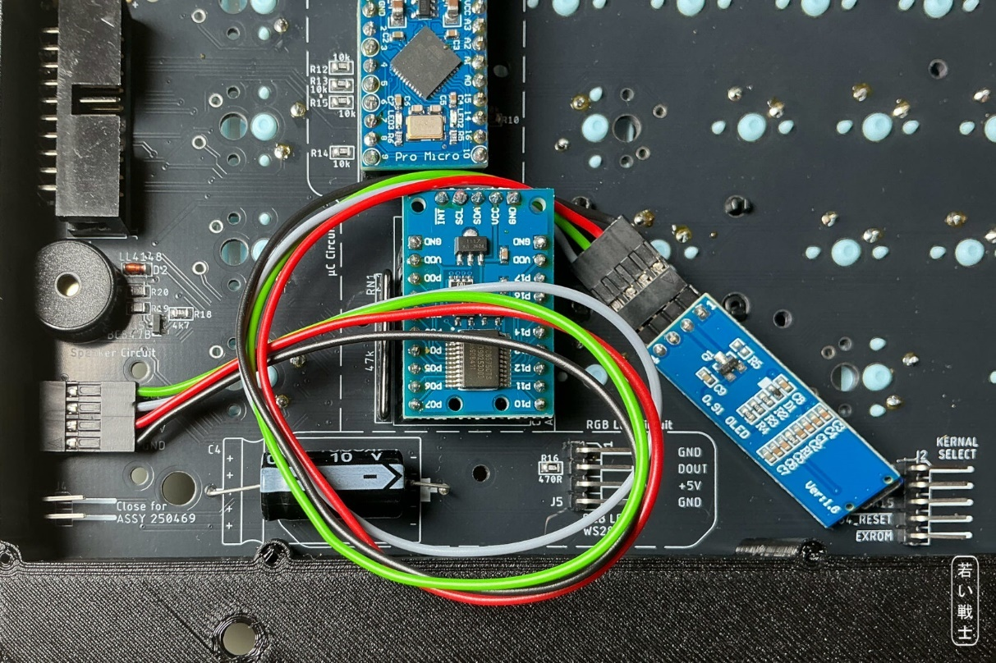
Figure 39: 0.91" OLED display connected to J7
The 5mm hole in the PCB next to the left pin of the 1000µF capacitor is provided for routing the display cable through the board, if required.

Connector Pinouts

J1 - Keyboard Connector
2x10 box pin header 90°
Signal | Pin | Pin | Signal
GND | 1 | 2 | n.c.
RESTORE | 3 | 4 | +5V
ROW3 | 5 | 6 | ROW6
ROW5 | 7 | 8 | ROW4
ROW7 | 9 | 10 | ROW2
ROW1 | 11 | 12 | ROW0
COL0 | 13 | 14 | COL6
COL5 | 15 | 16 | COL4
COL3 | 17 | 18 | COL2
COL1 | 19 | 20 | COL7

J2 – Kernal Switcher
5 way pin header 90°
Pin | Kernal Switcher | Ultimate
1 | A13 | Left = uFreeze
2 | A14 | Menu = uMenu
3 | A15 | Right = uReset
4 | RESET | Not relevant
5 | EXROM | Not relevant

J3 & J8 – Power LED
3 way Molex KK2.54/KF2510, 90°
Pin | Signal
1 | LED+
2 | GND
3 | LED+

J4 – Short Board Jumper
2 way pin header 90°
Place if short board

J5 – RGB LED Strip
4 way pin header 90°
Pin | Signal
1 | GND
2 | Din (of LED strip)
3 | +5V
4 | GND

J6 – Reserved
Do not place. Reserve pins of the pro micro.
5 way pin header
Pin | Signal
1 | GND
2 | RX
3 | TX
4 | A3
5 | +5V

J7 – I²C Bus
4 way pin header, 90°
Pin | Signal
1 | SCL
2 | SDA
3 | +5V
4 | GND

Jumpers

JP1 – SW67/PREV to GND
JP1 connects switch SW67 (pin 1) to GND. This jumper is closed by default.
If no microcontroller (M2) is used, JP1 can be opened to allow SW67 to be hardwired to any other switch in the keyboard matrix.

JP2 – SW68/NEXT to GND
JP2 connects switch SW68 (pin 1) to GND. This jumper is closed by default.
If no microcontroller (M2) is used, JP2 can be opened to allow SW68 to be hardwired to any other switch in the keyboard matrix.

JP3 – Power LED
The microcontroller (M2 = Pro Micro) controls the power LED connected to J3 or J8.
If the Pro Micro is not installed and J3 or J8 is to be used for an “always-on” power LED, the corresponding jumper must be closed.
The advantage of this arrangement is that only the keyboard cable is required between the upper and lower halves of the case.

J4 – Short Board Jumper
See J4 – Short Board Jumper

Programming model

Pro Micro
Pro micro Pin | GPIO | Name | Direction | Description
1 | D0/TX | TX | Tbd | Reserved (J6 pin 3)
2 | D1/RX | RX | Tbd | Reserved (J6 pin 2)
5 | SDA/D2 | SDA | Bidir | I²C-Bus (M1 & J7 pin 2)
6 | SCL/D3 | SCL | Output | I²C-Bus (M1 & J7 pin 1)
7 | A6/D4 | /RESTORE | Input | RESTORE button (active low)
8 | D5 | SND_OUT | Output | Output for piezo buzzer
9 | A7/D6 | RGBOUT | Output | Output for RGB LED strip (J5 pin2)
10 | D7 | /INT6 | Input | Interrupt from PCF8575 GPIO Module
11 | A8/D8 | /C64RES | Bidir* | Signal for resetting the C64 and shift lock status, active low
12 | A9/D9 | PWRLED | Output | Output for power led (J3&8), active high
13 | D10/A10 | /EXROM | Bidir* | EXROM signal, active low
14 | D16 | KSW_A15 | Bidir* | Kernal address bit A15/ultimate freeze
15 | D14 | KSW_A14 | Bidir* | Kernal address bit A14/ultimate menu
16 | D15 | KSW_A13 | Bidir* | Kernal address bit A13/ultimate reset
17 | A0 | /SHORT_BRD | Input | J4 short board jumper, active low
18 | A1 | /P1 | Input | SW67/PREV switch, active low
19 | A2 | /P2 | Input | SW68/NEXT switch, active low
20 | A3 | A3 | tbd | Reserved (J6 pin 4)

Bidir*: A pin marked with an asterisk is designed to emulate an open-collector GPIO. When the signal is low, the GPIO pin actively drives the output low. When the signal is “high,” the GPIO pin is left floating (i.e. configured as an input). A pull-up resistor elsewhere in the circuit then pulls the signal to the required high level.
This is important when a digital signal can have multiple sources, such as /C64RES, which can originate from the C64 reset circuit, a reset button, or the Pro Micro.
It is particularly important for the Ultimate button signals, because the Ultimate 64/C64U uses 3.3 V logic levels, which are not necessarily 5 V tolerant.
Note: GPIO stands for General Purpose Input/Output. A GPIO pin does not have a fixed function; its operation is determined by the circuit to which it is connected.

Keyboard Matrix/PCF8575
The PCF8575 module (M1) is a 16-bit GPIO expander connected via the I²C bus.
Its primary purpose is to detect the keyboard matrix scan signals. If these signals are not detected, the Pro Micro uses the PCF8575 to actively scan the keyboard matrix at 125 times per second.
This provides the functionality required to use the keyboard as a USB keyboard with a keyboard layout suitable for VICE (C64 emulator).

M1 GPIO | Signal | Discription
P00 | ROW0 | Keyboard return signals:  These signals are read to detect the switches of the keyboard matrix, that are pressed.
P01 | ROW1
P02 | ROW2
P03 | ROW3
P04 | ROW4
P05 | ROW5
P06 | ROW6
P07 | ROW7
P10 | COL0 | Keyboard scan signal:  A bit pattern is written to the columns of the keyboard matrix.
P11 | COL1
P12 | COL2
P13 | COL3
P14 | COL4
P15 | COL5
P16 | COL6
P17 | COL7

The GPIO slave address is selected using the solder bridges on the bottom side of the module (see Figure 20). The correct address is 0x20.

Keycap Making
Options for obtaining or making the keycaps will be described or listed in the /Keycaps/pdf/ subfolder.
At the time of writing, some options are still being evaluated.

3D Printables
A mounting frame is required to install the keyboard inside a C64 or C64C. It can be found in the /3D printables/Mounting Frame/ subfolder.
An optional stiffener can be screwed to the solder side of the PCB. In my experience, it is not required, since the PCB already provides sufficient stability when screwed to the mounting frame.
A separate plate is not required. A plate is the level approximately 5 mm above the PCB, with cutouts for the keyboard switches. It is normally used to align 3-pin switches. Since 5-pin switches are recommended for this keyboard, a plate is not necessary.
There are, however, plates that serve as the top cover of the USB keyboard case. These can be found in the /3D printables/USB Keyboard Case/ subfolder.
There are two types of plate: regular and classic. The classic plate is only suitable if you want to use original Commodore keycaps from the 20th century. All other DIY and modern Commodore keycaps require the regular plate. The difference is the cutout and switch position for the 1.5U keycaps (Shift, Control, Restore, F-keys, etc.).
Both the mounting frame and the USB keyboard case are designed to fit on a 25 cm-wide 3D printer bed.
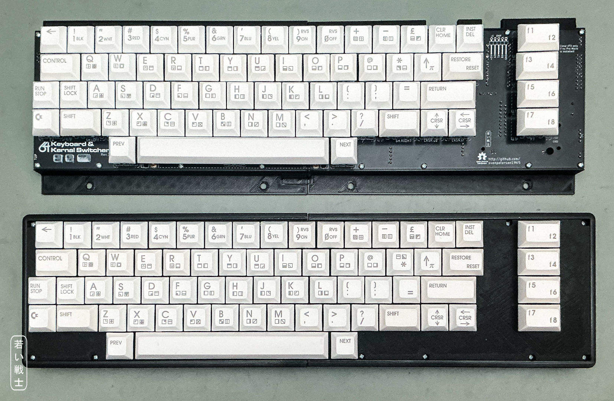
Figure 41: 3D printable mountinmg frame (top) and USB keyboard case (bottom)

Assembly

The Bill of Material
The complete circuit is divided into subcircuits, which can be populated optionally depending on the individual application.
The C64 keyboard PCB can always be fully populated, as none of the optional circuits interfere with the other functions, even if they are not used. The only disadvantage is that the keyboard will be slightly more expensive than necessary for a particular application.

The BOM (Bill of Materials) represents the fully populated version of the PCB. However, you may not require all components, depending on your intended use case.
The components are assigned to functional groups:
Short | Group
SL | Shift Lock Circuit
CTRL | Controller/pro micro
SPK | Piezo Buzzer
USBKB | USB-Keyboard
KSW | Kernal Switcher
RGB | RGB LED strip
I²C | I²C (OLED) Display

The switches and the keyboard connector J1 are always required.
The Shift Lock circuit should normally be populated, unless you find Shift Lock annoying. If it is omitted, the Shift Lock key has no function.
Every other option requires the controller (CTRL) / Pro Micro.
The SPK (piezo buzzer) is recommended. It provides audible feedback for the status of a reset and for the additional PREV and NEXT switches.
If you do not intend to use the keyboard as a USB keyboard, you can leave out the USBKB group. Including these components does not cause any problems, however. For USB keyboard operation, a Pro Micro with a USB-C connector is highly recommended.
The Kernal switcher requires only a small number of additional components. In addition to everything marked KSW in the BOM, the two additional switches SW67 and SW68 (PREV and NEXT) are required to switch between the Kernals.
The RGB LED strip is optional, as are the components marked RGB. If these components are populated but the LED strip is not connected, they do not cause any problems. SW67 and SW68 are required to switch between the LED patterns. The default state is off—without the switches, there is no way to activate the lighting.
The I²C bus is intended for connecting an OLED display. It could also be used for other devices, such as IC temperature sensors, but this functionality is not implemented in the firmware yet. Since an OLED display requires either a transparent case or a suitable cutout, it is entirely optional.

Assembly of the PCB

SMD component
Not everybody likes SMD components, but in my opinion, they are required for this project. I solder the SMD components with solder paste and a hot plate, but neither is required. You do not need a fancy hot-air rework station, either.
The components used are 0805 passives (which are still a reasonable size), SOT-23 transistors, and an SO-14 IC. For most of my life, I have soldered components of this size with normal solder and a soldering iron. When soldering SMD components, the use of additional flux (gel or liquid) is highly recommended.
If you are concerned about the component size because your eyes are over 40 years old, consider getting a headband magnifier. It can make a significant difference when working with small components.
Keep in mind that small components can easily get lost. Order a few more than specified in the BOM. There are already plenty of chip resistors orbiting the Earth after jumping off my tweezers.
Another option is to order the PCBs with the SMD components already assembled. I have only used this service with JLCPCB so far. A pick-and-place file is included in the project data in the format preferred by JLCPCB, as is the BOM.
Since I have not yet ordered assembled PCBs, I cannot say how much additional preparation is required. Both files will need to be edited. First, the non-SMD components should be removed. It is unlikely that JLCPCB will not have the required components available. Once the component placement is displayed, check the orientation carefully. In particular, the diodes, transistors, and ICs may not be oriented correctly and will need to be checked and corrected.
If you decide to place the SMD components yourself, solder them first, before installing the larger components. A very fine soldering tip is not necessary. I prefer a beveled tip approximately 2 mm wide as my general-purpose tip and rarely use anything else. It is wider than the pin spacing of an SO-14 IC, but that is not a problem:
The flux will do the magic!
I have to admit that I used soldering tips that were far too fine for at least 40 years.

The Through Hole Components

The Pro Micro (M2)
The Pro Micro usually comes with two 12-pin headers that are not soldered. The module is mounted using two corresponding socket strips, which are soldered to the keyboard PCB. This method makes it easier to install the module with properly aligned pins.
- Plug the pin headers into the socket strips.
- Insert the **socket strips—not the pin headers—**into the keyboard PCB.
- Place the Pro Micro onto the pin headers, with the components facing upward.
- Solder the pin headers to the Pro Micro.
- Solder the socket strips to the keyboard PCB on the solder side. The USB connector must face the edge of the PCB, as indicated by the silkscreen.

The GPIO extension: PCF8575 Module
This module is, as stated previously, only required for the USB keyboard version.
The first step is to set the I²C address bits correctly. On the solder side of the module, there are three solder bridges labeled A0, A1, and A2. All three solder bridges must connect to GND; otherwise, the Pro Micro cannot communicate with the module. See Figure 20.
The module comes with two 10-pin headers. It also includes a 5-pin 90° angled header, which is not suitable for this project. Please use the straight 5-pin header specified in the BOM instead.
As with the Pro Micro, the module should be installed with the pins properly aligned. The installation procedure is the same as for the Pro Micro.

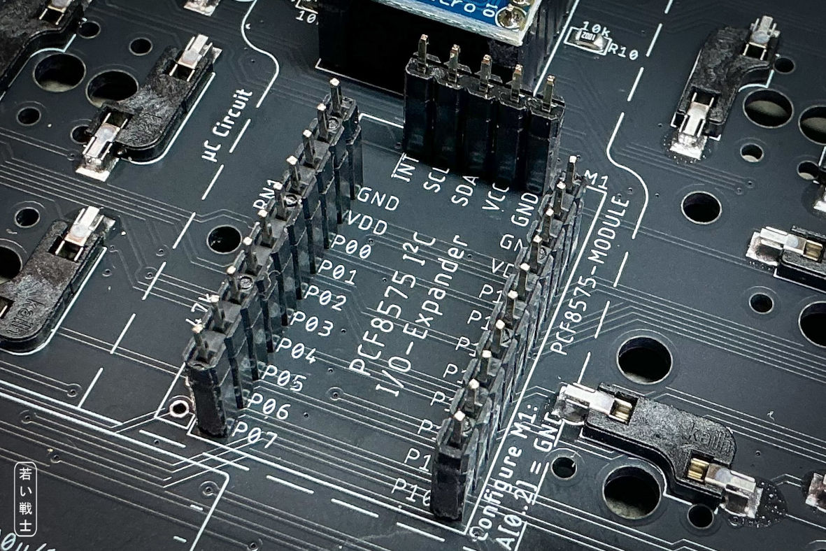
Figure 42: GPIO module - headers inserted (pin header up, socket stripe down
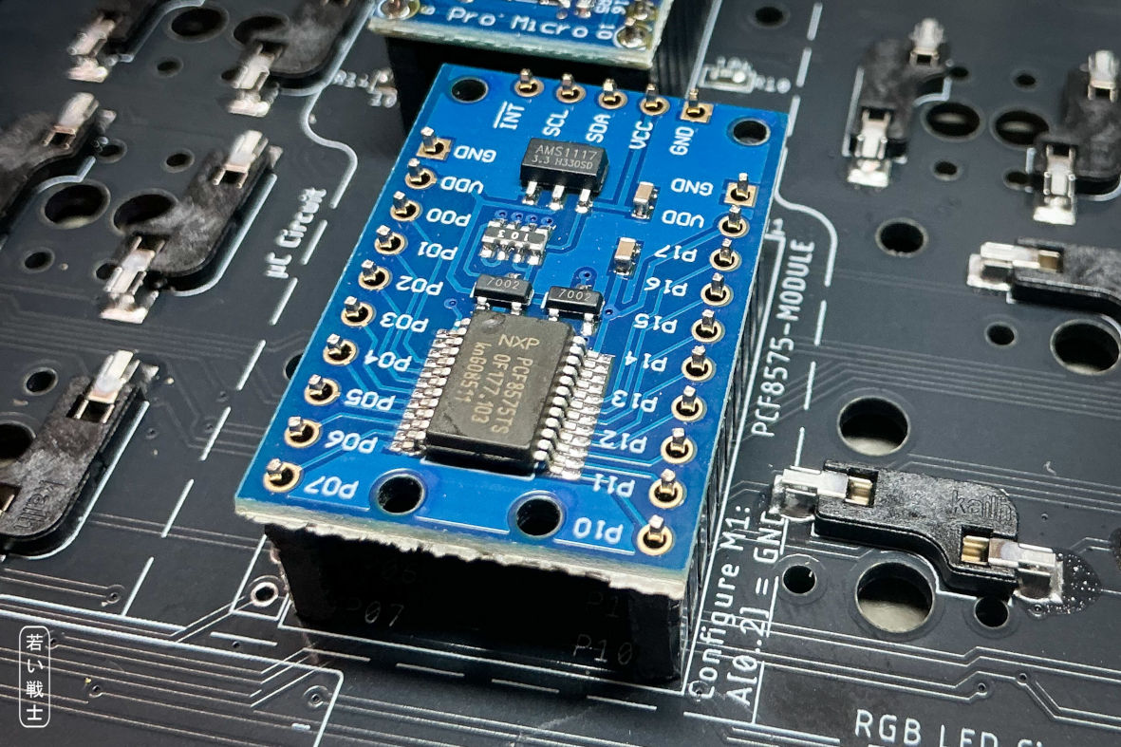
Figure 43: GPIO module before soldering
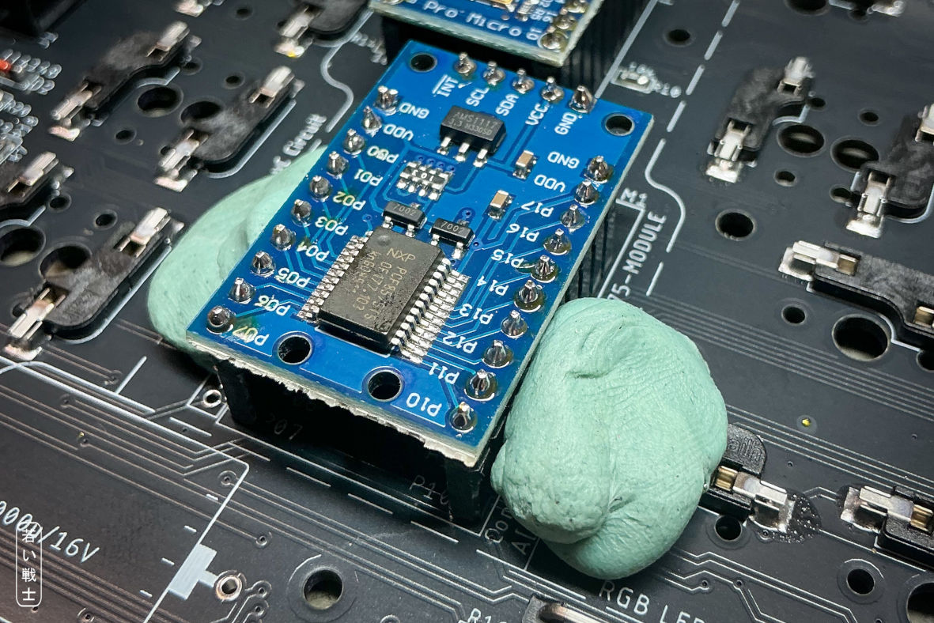
Figure 44: GPIO module after soldering (Held by blue tack)
For temporarily holding components in position, I use the popular Blu Tack. It is sufficiently sticky, can be reused many times, and is particularly useful for components that tend to fall out when the PCB is flipped over for soldering.

Remaining components
It does not matter whether the other through-hole components are soldered before or after the modules.
The switches should be installed last.

Stabilizers
It is a good idea to install the stabilizers before soldering in the switches. This leaves enough space to apply the moderate amount of force required to install them.
The wire of the 7U stabilizer runs above the spacebar switch, while the wire of the 2U stabilizer runs below the RETURN switch (see Figure 44).
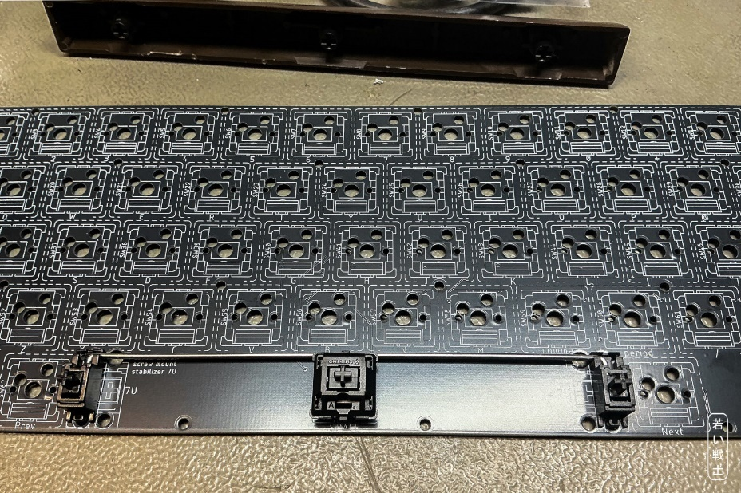
Figure 45: 9U stabilizer
9U Stabilizer:
The 9U stabilizer is only required if you want to use classic keycaps.
To make a 9U stabilizer, take another stabilizer and bend the replacement wire according to drawing 223-3-03-01 in the /9U_stabilizer/ subfolder. The required material is 1.5 mm spring-steel wire (see Figure 43). You will also find a documentation about making a 9U stabilizer wire in the said subfolder.
Note: The C64U and Blingboard64 space bars use a 7U stabilizer, which is relevant if you intend to use these keycaps.

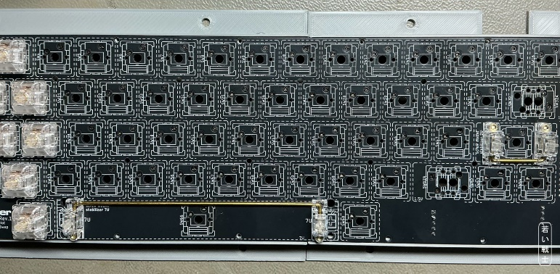
Figure 46: Keyboard with stabilizers, switches already installed

Switches and SHIFT LOCK LED
Before soldering the keyboard switches, check whether the LED should be installed before or after the Shift Lock switch.
There are generally two types of switches:
- On some switches, the LED is installed above the switch.
- Switches with a light guide can have the LED installed underneath. In this case, the light guide must first be removed by pressing it out from below, and the LED must be soldered before the switch is installed.
The LED is polarized. The shorter pin is the cathode (-) and the longer pin is the anode (+).
The high-brightness LED specified in the BOM can be somewhat confusing because its internal construction may make the polarity appear different. Use the pin lengths to determine the polarity, not the internal appearance of the LED.
The PCB silkscreen indicates the correct polarity. Unfortunately, on earlier PCB revisions this marking is covered by the switch once the switch has been installed. The polarity issue is corrected in later PCB revisions.
The anode (+) points toward the RUN/STOP key.
If your switches have light guides, remove the light guide only from the SHIFT LOCK switch. The light guides in all other switches should remain installed.
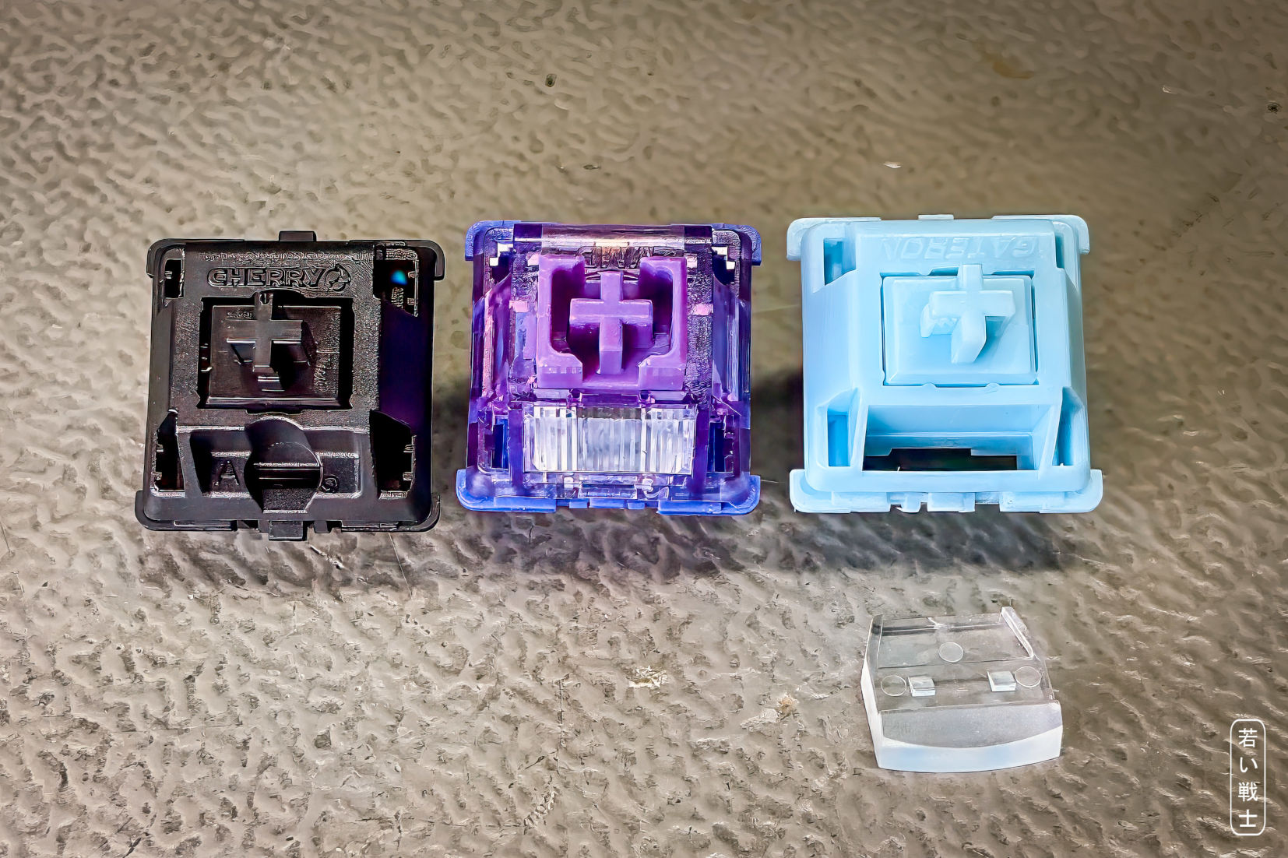
Figure 47: left to right: Switch with top entry LED configuration, with light guide, light guide removed

Cable Making

The Ribbon Cable
There is one ribbon cable: the keyboard cable connecting the keyboard to the C64 keyboard connector PCB (see drawing no. 224-3-01-0*, file /C64 Keyboard Connector PCB/Rev. 0/pdf/KB-Cab.pdf).
The cable uses a 2×10-way IDC receptacle on one end and a MicroMatch (IDC) connector on the other. The only tool required is a small vice.
Insert the cut ribbon cable into the connector, making sure that the red wire (wire no. 1) is aligned with pin 1, which is marked by a triangle/arrow on the connector. Then compress the connector in the vice.
Note that the 2×10-way connector has a strain relief. This causes the connector to be rotated by 180° when the strain relief is installed.
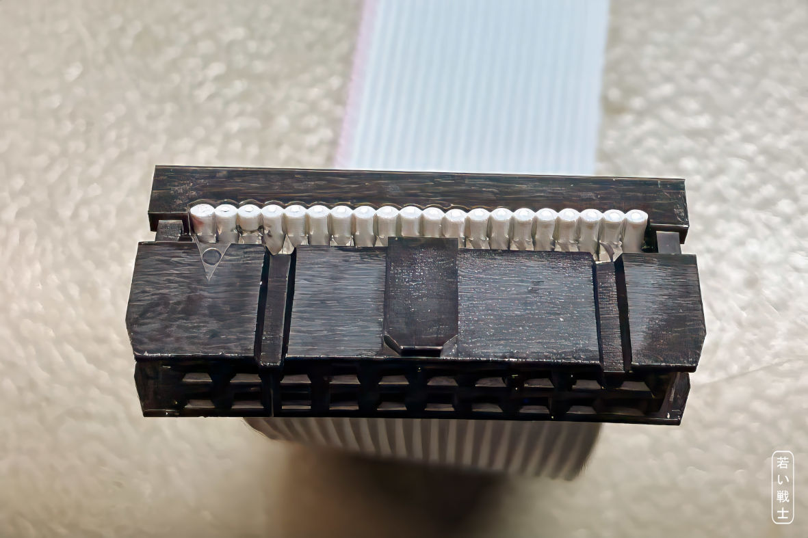
Figure 48: IDC receptacle - ribbon cable aligned
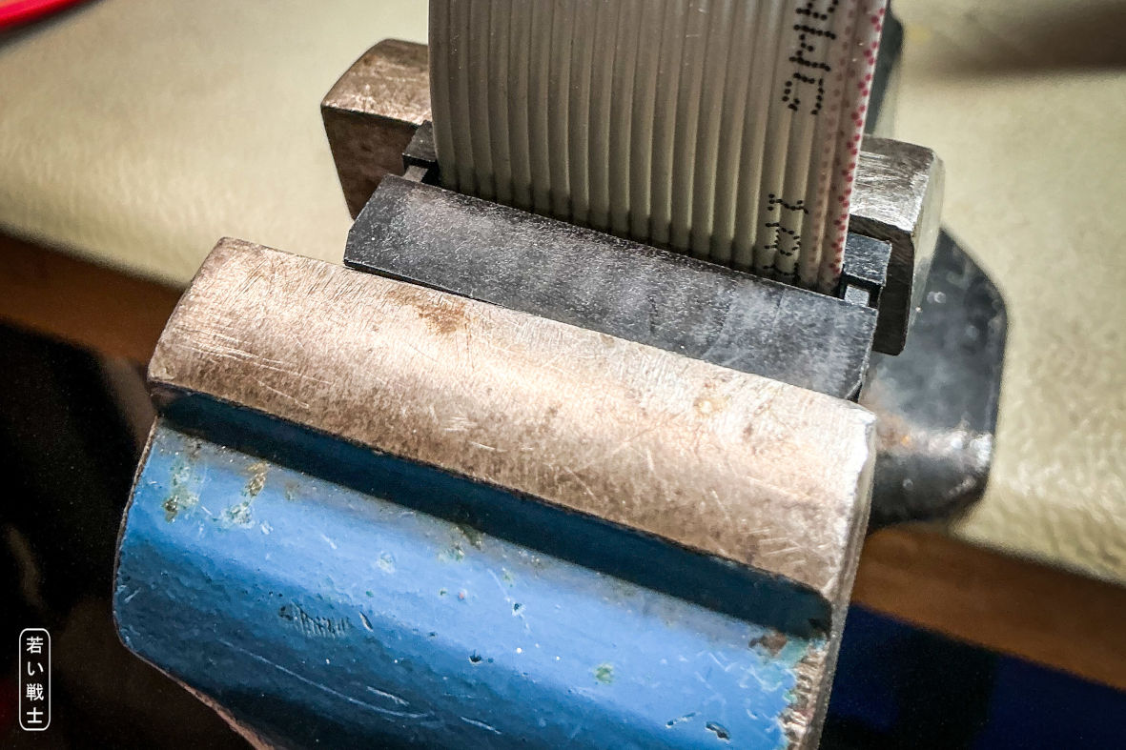
Figure 49: IDC receptacle in the vice, before compressing
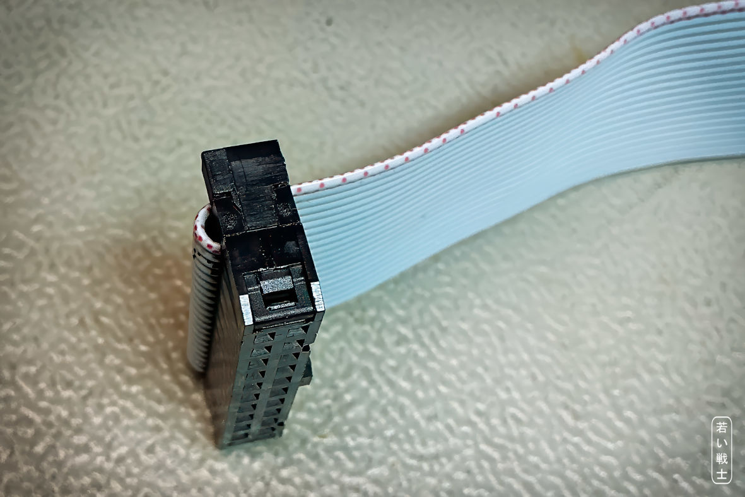
Figure 50: IDC receptacle - strain relief installed
The MicroMatch connector has a nipple that marks pin 1. There is no strain relief for this connector.
When compressing the connector with a vice, take care not to break off the pin-1 marking nipple.
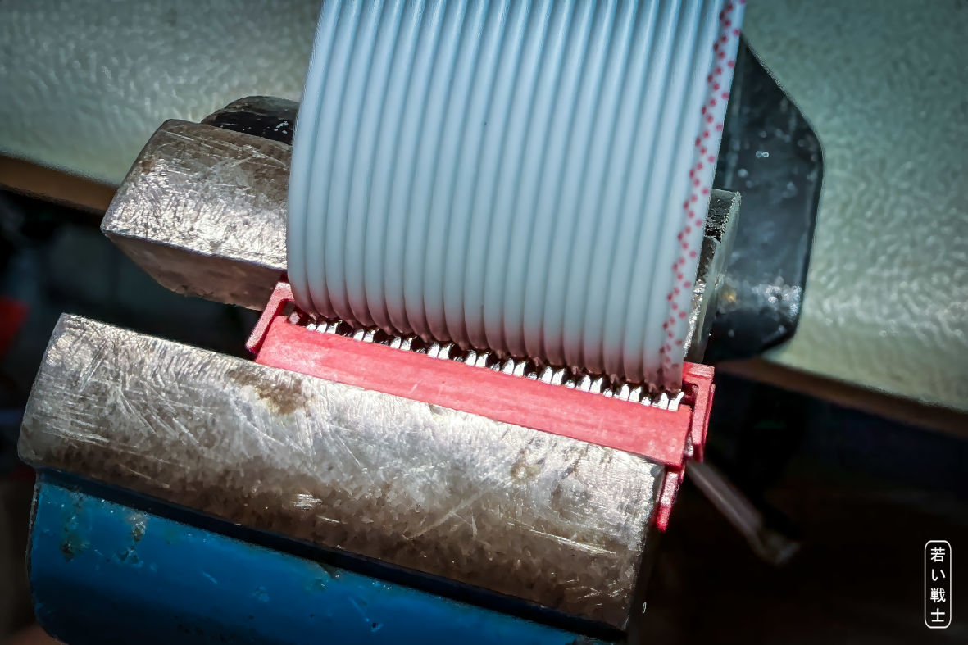
Figure 51: MicroMatch connector in vice with adjusted ribbon cable (
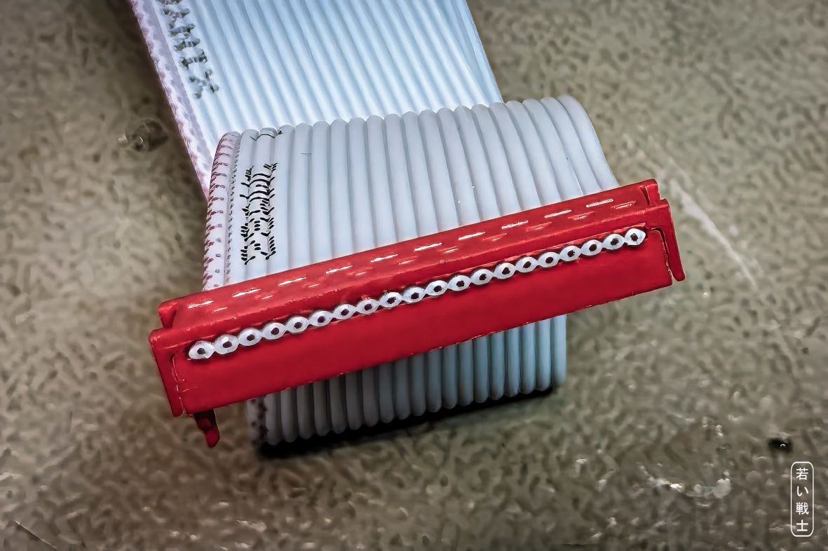
Figure 52: MicroMatch connector properly installed

The Dupont Cable(s)
The cables are designed to work with ready-made Dupont cables, which are readily available. These are ribbon cables with pre-crimped single-pin female Dupont connectors.
You will need 40 cm cables.
The simplest solution is to tear off the required number of individual wires from the ribbon cable and use them as they are.
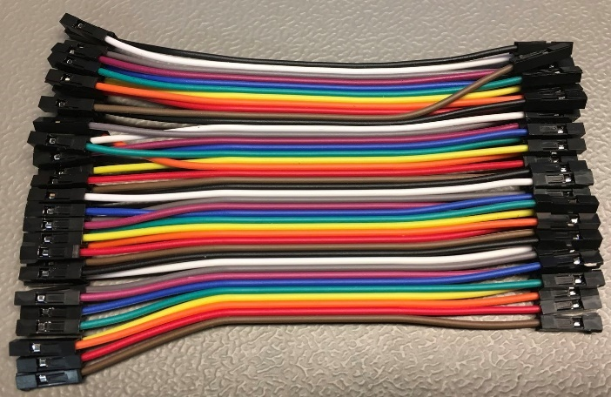
Figure 53: Ready-made Dupont cable (the length in the picture is short for photographic purposes)
A better solution is to use additional Dupont crimp housings. Remove the individual single-pin housings from the pre-crimped wires and replace them with 5-pin and 3-pin housings as required.
This method does not require a crimping tool, since the wires are already crimped. It also has the advantage of keeping the wires grouped correctly, making it much less likely that the pins will be mixed up.
The required Dupont housings are commonly available in assortment boxes.
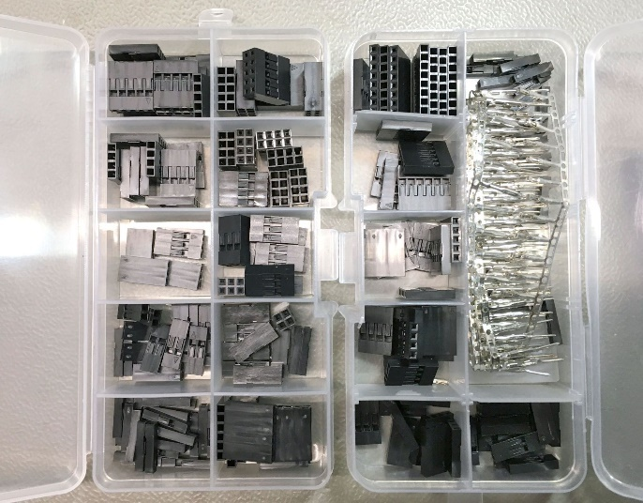
Figure 54: Dupont connector assortment box
For cables made to exactly the required length, you can use a crimp tool and crimp the terminals yourself.
The main problem with crimping Dupont terminals is that many tools are marketed as “Dupont” crimp tools but are not actually suitable for these terminals. The tool must form the insulation crimp correctly so that the finished terminal fits properly into the crimp housing.
The only crimp tool for Dupont terminals that I have used successfully is the IWISS SN-025.

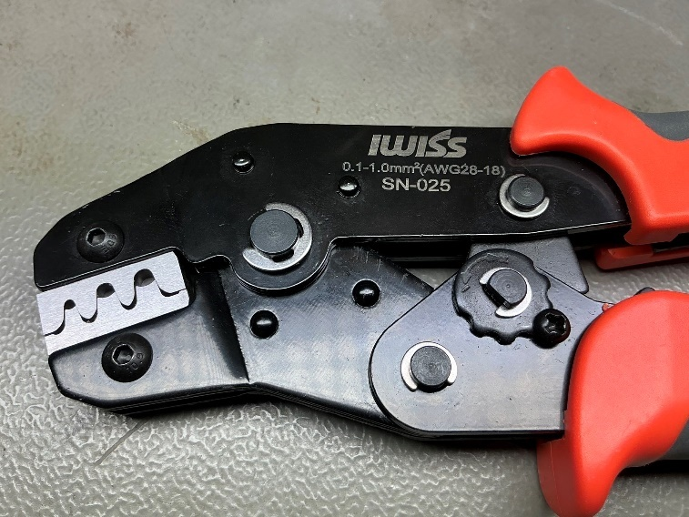
Figure 55: IWISS SN-025 crimp tool
The choice is yours.
In my opinion, buying a crimp tool solely for this project does not make much sense if it is going to end up as unused drawer clutter. However, if you intend to make your own crimped cables for other projects as well, I can recommend this tool.
Dupont assortment boxes are the simplest way to obtain all the crimp housings you need, typically including 3-way, 5-way, and optionally 4-way housings.

Wiring Up the Keyboard

USB Keyboard
The USB keyboard does not require any external wires.

Keyboard Matrix
The keyboard Matrix is wired to the C64 mainboard keyboard connector through the C64 Keyboard Connector PCB (project no. 224 in this repository). See Figure 12.

Kernal Switcher
The Kernal Switcher J2 is connected to the Kernal Adapter and the mainboard via the cable from drawing 223-3-01-00. See chapter 5.8, Figure 23, Figure 29 and Figure 30.

Ultimate Buttons
In Ultimate mode, the Kernal Switcher J2 can control the buttons pin header on the Ultimate/C64 Ultimate buttons pin header via the cable from drawing 223-3-02-00.
See chapter 5.9, Figure 31 and Figure 32.

OLED Display (optional)
The OLED displays have different pin outs. Just connect VCC to +5V, GND to GND, SDA to SDA, SCK to SCK. Use Dupont cables (self-fabricated or bought). See chapter 5.11.

The LED Strip cable (optional)
The LED strip cable is soldered to the WS2812B LED strip (see Figure 35 and Figure 36).

Series Production
If you plan to produce this project in series, the hot-swap version might be a good choice, as most of the components are SMD and can be machine-placed and soldered. Only the connectors and the sockets for the Pro Micro and GPIO module need to be soldered by hand. The standard version is ok for prefabrication of SMD places boards.
The /JLCPCB Assembly/ folder contains a BOM and a pick-and-place file (CP1) in a format compatible with the JLCPCB PCBA (PCB assembly) process. It might still require some work to get the assembly on track, though.

Product References and Disclaimer
Throughout this documentation, I mention specific products, brand names, and suppliers. These references are provided solely for informational purposes and are not intended as advertising or endorsements. I have not received any compensation or other benefits for mentioning them. I refer to these products and suppliers simply because I have used them myself and can therefore share my personal experience with them.

Revision History

Rev. 0
- First prototype: requires a botch wire for the shift lock circuit. Requires a Pro Micro controller.

Rev. 1
- Shift Lock Debounce circuit changed
- Power-on Reset added
- This requires a botch to suppress the power-on pulse. The problem is only effective, if no Pro Micro is populated

Rev. 2
- The Power-on Reset and Shift Lock circuit work properly now

